

**"Predictive Modelling of Air Quality Index (AQI) Across Diverse Cities and States of India Using Machine Learning: Investigating the Influence of Punjab's Stubble Burning on AQI Variability"**

**by**

**Kamaljeet Kaur Sidhu**

**Student Id: 19489382**

**Supervised by**

**Kazeem Oseni**

Submitted in partial fulfilment of the requirements of

the School of Computer Science & Engineering

of the University of Westminster

for award of the Master of Science

JANUARY 2024

|  |
| --- |
| **DECLARATION** |

I, Kamaljeet Kaur Sidhudeclare that I am the sole author of this Project; that all references cited have been consulted; that I have conducted all work of which this is a record, and that the finished work lies within the prescribed word limits.

This has not previously been accepted as part of any other degree submission.

|  |  |
| --- | --- |
| Signed : |  |
| Date : |  |  |

|  |
| --- |
| **FORM OF CONSENT** |

I, Kamaljeet Kaur Sidhuhereby consent that this Project, submitted in partial fulfilment of the requirements for the award of the MSc degree, if successful, may be made available in paper or electronic format for inter-library loan or photocopying (subject to the law of copyright), and that the title and abstract may be made available to outside organisations.

|  |  |
| --- | --- |
| Signed : |  |
| Date : |  |  |

**ABSTRACT**

Air pollution is a common and serious problem in today's world, and it is a threat to human species. Air pollution not only affects the human health, but it can lead to the extinction of human beings, if not handled and tackled carefully. To address this issue proactively, people should be aware of their surroundings means the environment where they survive. With this motive, this research has predicted the AQI based on different air pollutants concentration in the atmosphere.

The dataset used for this research has been taken from the official website of CPCB. The dataset has the air pollutants concentration from 22 different monitoring stations of different cities of Delhi, Haryana, and Punjab. This data is checked for null values and outliers, there presence in a dataset may degrade the performance of the model. The dataset is checked for stationarity by applying the Dickey-Fuller Test. The p-value is used to check the dataset, it will show the data as stationary or not.

Further different ML models like CatBoost, XGBoost, Random Forest, SVM regressor, time series model SARIMAX and deep learning model LSTM has been used to predict AQI. For performance evaluation of different models I used MSE, RMSE ,MAE and R2. It is observed that Random Forest performed better as compared to other models.

**Keywords**: Air Quality Indexing, Random Forest, SARIMAX, Dickey-Fuller Test, Mean Absolute Percentage Error, Imputation, Missing Values, Outliers

**Table of Contents**

**List of Figures** 8

**List of Tables** 12

**List of Acronyms** 13

**1.** **INTRODUCTION** 15

**1.1** **Aim and Objective** 16

**1.1.1 Aim** 16

**1.1.2 Objective** 16

**1.2** **Research Questions** 16

**1.3** **Scope of the thesis** 17

**1.4** **Report Organization** 17

**2.** **Background** 17

**2.1 Air Quality Index:** 17

**3.** **Related Work** 20

**3.1 Use of ML to predict AQI.** 20

**3.2 Influence of stubble burning on AQI** 24

**4. Data Understanding** 25

**4.1 Dataset Description** 25

**5. Data Preprocessing** 26

**5.1 Missing Values** 26

**5.1.1 Handling Missing Values** 27

**5.2 Correlation Matrix** 30

**5.2.1 Pearson’s Correlation** 31

**5.3 Feature Selection** 32

**5.4 Data Description** 33

**5.4 Outliers** 33

**5.4.1 Identifying Outliers** 33

**5.4.2 Data Investigation for Outliers** 38

**5.4.3 Handling Outliers** 40

**5.5 Data Description after Outliers** 45

**5.6 Feature Engineering** 45

**5.6.1 Feature engineering Techniques for ML** 45

**6. Methodology** 47

**6.1 Literature Review** 47

**6.1.1 Inclusion criteria:** 47

**6.1.2 Exclusion criteria:** 47

**6.2 Visualization** 47

**6.2.1 Impact of COVID-19 on burning activities:** 50

**6.2.2 Seasonality and Relation between different air pollutants concentration and AQI.** 52

**6.3 Experimentation** 53

**6.3.1 Data Split** 54

**6.3.2 Machine Learning Models** 54

**1.** **CatBoost:** 54

**1.1 Hyper Parameters for CatBoost** 54

**2.** **XGBoost:** 55

**2.1** **Hyper Parameters for XGBoost** 56

**3.** **Random Forest Regressor:** 56

**3.1** **Hyper Parameters for Random Forest Regressor** 57

**4.** **Support Vector Regressor:** 57

**4.1** **Hyper Parameters for Support Vector Regression** 58

**6.3.3 Time Series Model** 58

**1.** **SARIMAX** 58

**2.** **Configuring the SARIMA Model** 59

**3.** **Use of SARIMAX** 60

**4.** **Testing for SARIMA Model configuration** 61

**4.1** **The Dickey-Fuller test** 61

**4.2** **ACF** 62

**4.3** **PACF** 63

**6.3.4 Deep Learning Model** 63

**1.** **LSTM** 63

**1.1 Important Hyperparameters for LSTM** 64

**1.2 Hyperparameters used in this research** 64

**7 Results** 65

**7.1 Experimentation Outcome** 65

**7.1.1 Performance Metrics** 65

**7.1.2 Machine Learning Models** 66

**1.** **CatBoost Regressor** 67

**1.1 Visualization of model predictions VS Actual values:** 68

**1.2** **Performance matrix evaluation:** 70

**1.3 Important Features for CatBoost R:** 70

**1.4 Residuals Distribution:** 71

**2.** **XGBoost model** 71

**2.1 Visualization of model predictions VS Actual values:** 72

**2.2** **Performance matrix evaluation:** 74

**2.2 Residuals Distribution:** 74

**3.** **Random Forest model** 75

**3.1** **Performance Matrix Evaluation** 75

**3.2 Visualization of model predictions VS Actual values:** 76

**3.2** **Residuals Distribution:** 77

**4.** **Support Vactor Regressor** 77

**4.1 The residuals Distributions** 79

**7.1.3 Time Series Model** 79

**1.** **SARIMAX** 79

**1.1** **Theoretical Understanding of parameters** 79

**1.2** **Performance Matrix Evaluation** 80

**1.3** **Residuals Distribution** 80

**7.1.4 Deep Learning Model** 81

**1.** **LSTM** 81

**1.1** **Performance Matrix Evaluation of LSTM** 82

**7.2 Experimentation and Results Evaluation** 82

**8. Limitations** 83

**9. Future Scope** 84

**10. Conclusion** 84

**References:** 84

# **List of Figures**

**Figure 2.1** Formation of an aggregated AQI

**Figure 2.2** Formula to calculate AQI.

**Figure 2.3** Breakpoints for AQI Scale 0-500 (units: µg/m3 unless mentioned otherwise)

**Figure 2.4** Health Statements for AQI Categories

**Figure 5.1** Missing values

**Figure 5.2** Temporal Feature Extraction

**Figure 5.3** Mean imputation

**Figure 5.4** Outcome ofMean imputation

**Figure 5.5** Finding the count of missing value by year, month, and monitoring station.

**Figure 5.6** Outcome ofSQL Query

**Figure 5.7** Filling missing values with 0

**Figure 5.8** Outcome of missing value imputation shown in Figure 5.7

**Figure 5.9** Correlation Matrix

**Figure 5.10** Correlation Values in ascending order

**Figure 5.11** Descriptive Statistics of the dataset

**Figure 5.12** Interpretation of Box Plot

**Figure 5.13** Outliers in PM 2.5 Concentration

**Figure 5.14** Outliers in PM 10 Concentration

**Figure 5.15** Outliers in NO Concentration

**Figure 5.16** Outliers in NO2 Concentration

**Figure 5.17** Outliers in NOx Concentration

**Figure 5.18** Outliers in NH3 Concentration

**Figure 5.19** Outliers in CO Concentration

**Figure 5.20** Outliers in SO2 Concentration

**Figure 5.21** Outliers in AQI Concentration

**Figure 5.22** Unusual Data Points

**Figure 5.23** The number of null values for outliers

**Figure 5.24** Formula for Time Interpolation

**Figure 5.25** PM 2.5 After handling Outliers

**Figure 5.26** PM 10 After handling Outliers

**Figure 5.27** NO After handling Outliers

**Figure 5.28** NO2 After handling Outliers

**Figure 5.29** NOx After handling Outliers

**Figure 5.30** CO After handling Outliers

**Figure 5.31** SO2 After handling Outliers

**Figure 5.32** AQI After handling Outliers

**Figure 5.33** Output of Time Interpolation

**Figure 5.34** Descriptive Statistics after Outliers

**Figure 5.35** One Hot Encoding for Spatial Columns

**Figure 5.36** One Hot Encoding Output

**Figure 6.1** Research Area on Map

**Figure 6.2** Different cities where Monitoring Stations are located on Map.

**Figure 6.3** Before and duringBurning period from March to May.

**Figure 6.4** Before and duringBurning period from September to November

**Figure 6.5** PunjabApril 2020

**Figure 6.6** PunjabApril 2022

**Figure 6.7** PunjabNovember 2020

**Figure 6.8** PunjabNovember 2022

**Figure 6.9** Heatmap of monthly average AQI in Delhi from 2019-2023

**Figure 6.10** Heatmap of monthly average AQI in Haryana from 2019-2023

**Figure 6.11** Heatmap of monthly average AQI in Punjab from 2019-2023

**Figure 6.12** PM 2.5/ AQI

**Figure 6.13** PM10/AQI

**Figure 6.14** Explanation of the CatBoost algorithm

**Figure 6.15** Basic structure of the level-wise XGBoost tree model

**Figure 6.16** The schematic diagram of RFR

**Figure 6.17** The schematic diagram of SVM

**Figure 6.18** Seasonality components of Delhi AQI dataset

**Figure 6.19** The Dickey-Fuller test

**Figure 6.20** ACF

**Figure 6.21** PACF

**Figure 6.22** The memory cell of LSTM

**Figure** 7.1 MAE

**Figure** 7.2 MSE

**Figure** 7.3 RMSE

**Figure** 7.4 R2

**Figure 7.5** CatBoost Regressor Model

**Figure 7.6** CatBoost R Predictions of October 2022

**Figure 7.7** CatBoost R Predictions of November 2022

**Figure 7.8** CatBoost R Predictions of December 2022

**Figure 7.9** CatBoost R Predictions of January 2023

**Figure 7.10** Feature Importance for CatBoost Regressor Model

**Figure 7.11** Residuals Distribution in CatBoost Regressor Model

**Figure 7.12** XGBoost Regressor Model

**Figure 7.13** XGB R Predictions of October 2022

**Figure 7.14** XGB R Predictions of November 2022

**Figure 7.15** XGB R Predictions of December 2022

**Figure 7.16** XGB R Predictions of January 2022

**Figure 7.17** Residuals Distribution in XGB Regressor Model

**Figure 7.18** RF Regressor Model Predictions

**Figure 7.19** RF Regressor Model November 2022 (Punjab)

**Figure 7.20** RF Regressor Model July 2022 (Punjab)

**Figure 7.21** Residuals Distribution in RF Regressor Model

**Figure 7.22** Support Vactor Regressor Model

**Figure 7.23** Residuals Distribution in SVR Model

**Table 7.24** SARIMAX Predictions (Delhi)

**Figure 7.25** Residuals Distribution of SARIMAX Model

**Figure 7.26** LSTM Predictions

**Figure 7.27** Performance Matrix of all the used Models

**List of Tables**

**Table 3.1** Literature review on predicting AQI using ML.

**Table 5.1** Outliers in Air Pollutants Concentration for each state

**Table 7.1** Performance Metrics CatBoost

**Table 7.12** Performance Metrics XGBoost Regressor

**Table 7.13** Performance Metrics Random Forest Regressor

**Table 7.14** Performance Metrics SVM Regressor

**Table 7.15** Performance Metrics of SARIMAX

**Table 7.16** Performance Metrics of LSTM

**Table 7.17** Performance Metrics of all the models

# **List of Acronyms**

**AQI - Air** Quality Index.

**PM2.5** - Particulate Matter 2.5 micrometres or smaller

**PM10** - Particulate Matter 10 micrometres or smaller

**NO** - Nitric Oxide

**NO2** - Nitrogen Dioxide

**NOX** - Nitrogen Oxides (NO + NO2)

**NH3** - Ammonia

**CO** - Carbon Monoxide

**SO2** - Sulfur Dioxide

**O3** - Ozone

**Benzene** - Aromatic hydrocarbon

**Toluene** - Aromatic hydrocarbon

**Xylene** - Aromatic hydrocarbon

**T** - Temperature

**RH** - Relative Humidity

**WS** - Wind Speed

**WD** - Wind Direction

**SR** - Solar Radiation

**BP** - Barometric Pressure

**AT** - Ambient Temperature

**RF** - Rainfall

**TOT-RF** - Total Rainfall

**LASSO** Least Absolute Shrinkage and Selection Operator.

**MAE** Mean Absolute Error.

**RMSE** Root Mean Square Error.

**SVR** Support Vector Regression.

**EDA** Exploratory Data Analysis.

**ML** Machine Learning

**KNN** - k-Nearest Neighbours

**GNB** - Gaussian Naive Bayes

**SVM** - Support Vector Machine

**RF** - Random Forest

**XGBoost** - eXtreme Gradient Boosting

**DT** - Decision Tree

**ANN** - Artificial Neural Network

**SARIMA** - Seasonal Autoregressive Integrated Moving Average

**LSTM** - Long Short-Term Memory (a type of recurrent neural network)

**SMOTE** - Synthetic Minority Over-sampling Technique

**CPCB** – Central Pollution Control Board

**WHO –** World Health Organisation

**SEPB** - Shijiazhuang Environmental Protection Bureau

**CEPB -** Chongqing Environmental Protection Bureau

**BMEMC** - Beijing Municipal Environmental Monitoring Centre

# **INTRODUCTION**

Putting all the life threats aside, air pollution is a major and pressing public health threat or a silent killer. It is estimated by WHO, around 7 million people die every year from exposure to deadly fine particles in polluted air that lead to diseases such as stroke, heart disease, lung cancer, chronic obstructive pulmonary diseases, and respiratory infections, including pneumonia. Both ambient (outdoor) and household (indoor) air pollution are harmful for health (“Air pollution,” 2023). Ambient (outdoor) air pollution is estimated to have caused 4.2 million premature deaths worldwide in 2019 (“Ambient (outdoor) air pollution,” 2022.). India is one of the most polluted countries, where the air quality reaches hazardous levels. New Delhi - the capital of India has records of the highly bad air quality. Flights in and out of New Delhi International Airport are often cancelled due to the reduced visibility associated with air pollution (Manisalidis et al., 2020).

The Air Quality Index (AQI) is a daily basics expected measure of air pollution levels in the environment. It informs about the short-term potential health effects on well-being. Being aware of AQI helps to safeguard everyone from effects of bad air quality. Even the low levels of AQI can impact the health of susceptible and sensitive individuals like old people, children, and patients. As, Short-term exposure to air pollutants is closely related to COPD (Chronic Obstructive Pulmonary Disease), cough, shortness of breath, wheezing, asthma, respiratory disease, and high rates of hospitalization. The acute and long-term exposure to air pollution is a serious threat for health in western industrialized countries. However, the burden of this problem is even more serious in developing countries like India, where population explosion along with widespread industrialization coupled with urbanization have resulted in dense urban centres with poor air quality (Manisalidis et al., 2020).

According to the Indian Government (CPCB), AQI range is from 0-500, from 0 being good and 500 being severe. There are eight major pollutants to be considered for AQI calculation, viz. PM 10 and PM 2.5, CO, O3, NO2, SO2, NH3, and Pb. To calculate AQI, data for a minimum of three pollutants must be present, of which one should be either PM10 or PM2.5, AQI ranging from 0-500 has different concentrations for each pollutant and has health effects accordingly. However, the selection of parameters primarily depends on AQI objective(s), data availability, averaging period, monitoring frequency, and measurement methods (“FINAL-REPORT_AQI_.pdf”). Initially, for this study daily concentration of PM2.5 (ug/m3), PM10 (ug/m3), NO (ug/m3), NO2 (ug/m3), NOx (ppb), NH3 (ug/m3), SO2 (ug/m3), CO (mg/m3), Ozone (ug/m3), Benzene (ug/m3), Toluene (ug/m3), Temp (degree C), RH (%), WS (m/s), WD (degree), SR (W/mt2), Xylene (ug/m3) from 1st January 2019 to mid-October 2023 is considered.

There is a need for proactive air pollution prediction in a continuous manner to mitigate the harmful impacts of bad air quality. ML is one of the techniques which can be used to predict or suggest a solution for air pollutants. The collection of raw data, which is of not much use, once clubbed with various machine learning algorithms can be used to accomplish the task for example, predict the future. For this research different ML regression algorithms are considered including CatBoost, XGBoost, Random Forest, and SVR. Also, from a set of time series forecasting algorithms SARIMAX and from deep learning models LSTM is used to predict AQI for different monitoring station in Delhi, Haryana, and Punjab.

# **Aim and Objective**

# **1.1.1 Aim**

* Develop predictive models using machine learning algorithms to forecast AQI in different cities of three major states Punjab, Haryana, and Delhi.
* EDA (Exploratory data analysis) with focus to analyse temporal patterns, spatial distribution of AQI and investigate other major findings.
* Access the influence of stubble burning in Punjab and Haryana on AQI.

# **1.1.2 Objective**

To review literature related to chosen topic, understand the working of different algorithms, look for gaps in the existing studies to successfully predict the AQI and carry research forward with self-understanding of Data Analyst and Data Scientist skills.

# **Research Questions**

How machine learning can be used to predict AQI?

**Method opted:** Literature Review.

**Motivation:** There is a great collection of literature available describing the importance and process of applying ML to predict AQI.

What are the spatial and temporal patterns of AQI across different states?

**Method opted:** Visualization.

**Motivation:** Visualization is the best approach for exploratory data analysis like showcasing temporal patterns and spatial differences of AQI.

Which is the most effective machine learning algorithm and has the most accuracy in predicting the AQI?

**Method opted:** Experimentation.

**Motivation:** Experimentation is chosen for this research question because I build a model by training an algorithm to analyse the performance of algorithms. The main aim of the research is to find the most effective and accurate machine learning algorithm for the prediction of AQI.

What is the influence of stubble burning on AQI?

**Method opted:** Literature review.

**Motivation:** There are many research papers published on this topic. Therefore, literature review can be the most suitable method to this problem.

# **Scope of the thesis**

The main aim of the thesis is to develop a model to predict AQI. The models are built by training ML, time series and deep learning algorithms. ML algorithms including CatBoost, XGBoost, Random Forest and SVR. Time series algorithm SARIMAX and Deep Learning algorithm LSTM is used to predict AQI for multiple monitoring stations. Due to data availability issues at CPCB website, just five years of data from January 2019 to October 2023 is used for this research. The data for most of the meteorological factors is not sufficient to include in the algorithms.

# **Report Organization**

The part 1 of this paper is the introduction part which comprises of statistics on effects of air pollution, a brief description of AQI, different ML forecasting models used in this research, aim and objective of this research followed by the research questions to be carried out and scope of this research Part 2 is the background of this research and explain about AQI. Part 3 consists of related work, use of ML models to predict AQI and impact of stubble burning on AQI. In Part 4 is all about data understanding. Part 5 is all about preprocessing of data in detail. Part 6 is about the methodology used to resolve the research questions this section consists of visualization, experimentation, Using ML model and other ML techniques. Part 7 is the results section which highlights model experimentation outcome for different models. Part 8,9,10 is about limitations, future scope and conclusions.

# **Background**

# **2.1 Air Quality Index:**

The transformation of weighted values of individual air pollution related parameters like PM2.5, PM10, CO, NO, NOx, NO2, SO2, NH3, O3 etcetera into a single number is referred to AQI.

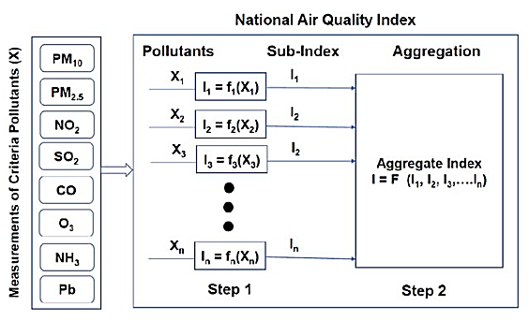

**Source:** (Verma, 2020)

**Figure 2.1** Formation of an aggregated AQI

The Formation of AQI involves the following two steps.

* Sub Index Calculation
* Aggregated Index Calculation

**Sub Index Calculation**

The general equation for the sub-index (Ii) for a given pollutant concentration (Cp), as based on ‘linear segmented principle is calculated as Ii= [(IHI - ILO/ BHI -BLO) * (Cp-BLO)] + ILO.

Each component used for this formation is explained below:

BHI = Breakpoint concentration greater or equal to given

Concentration.

BLO= Breakpoint concentration smaller or equal to given

Concentration.

IHI = AQI value corresponding to BHI

ILO = AQI value corresponding to BLO

Cp = Pollutant concentration

**Aggregated Index Calculation**

Aggregated Index (AQI/I) is calculated as follows.

AQI/I = Max (I1, I2… In).

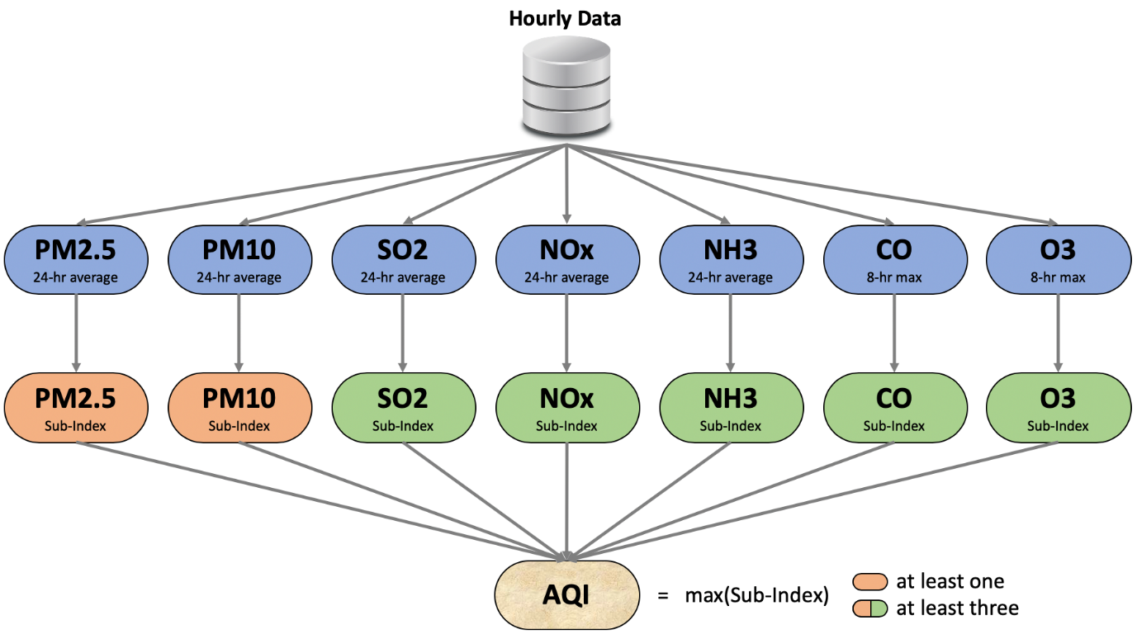

**Source:** (“Calculating AQI (Air Quality Index) Tutorial”)

**Figure 2.2** Formula to calculate AQI.

The standard of AQI calculation consider seven air pollutant parameters shown in Figure 2.2. For all the pollutants except CO and O3 the average of 24 hours concentration is taken for that day. It is mandatory to have at least 16 hours of data out of 24 hours to get the reading for that day. However, for CO and O3 the maximum out of 8 hours reading is considered as the concentration for that day. Further these measures are converted into sub-indexes based on set breakpoints for each pollutant.

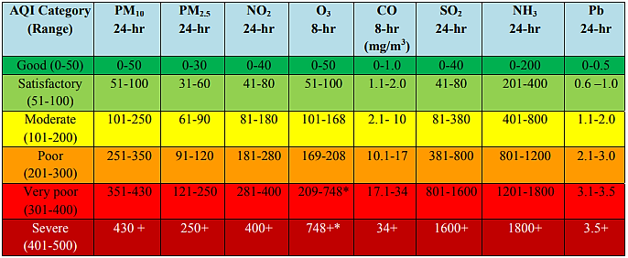

**Source:** (“displaypdf.pdf”)

**Figure 2.3** Breakpoints for AQI Scale 0-500 (units: µg/m3 unless mentioned otherwise)

It is possible to do not have any records sometimes when there is lack of measuring o lack of required data points. Overall AQI is the maximum Sub-Index with the condition that at least one of PM2.5 and PM10 should be available and at least three out of the seven should be available.

CPCB may consider reviewing the AQI breakpoints every three years after accounting the new

research findings on air pollution exposure and health effects (“displaypdf.pdf”).

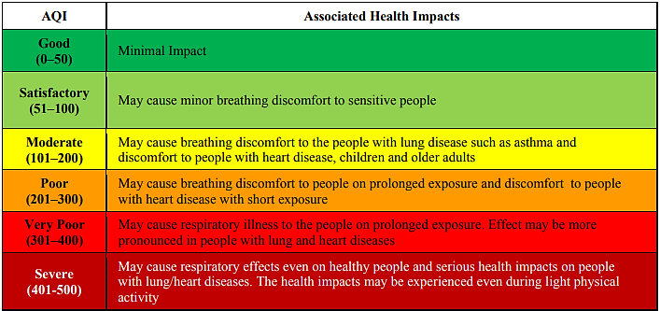

**Source:** (“displaypdf.pdf”)

**Figure 2.4** Health Statements for AQI Categories

# **Related Work**

This section contains detailed review of literature done related to prediction of AQI. The techniques of preprocessing, data analysis and predicting AQI has been studied and reviewed. Different ML algorithms, time series algorithm SARIMAX and deep learning algorithms LSTM are examined to understand why these approaches are capable to perform well in forecasting AQI.

# **3.1 Use of ML to predict AQI.**

(Kumar and Pande, 2023) presented the study, investigates six years of air pollution data from 23 Indian cities for air quality analysis and prediction. The data was taken from CPCB website from January 2015 to July 2020. The preprocessing steps are applied on the data and key features are selected using correlation analysis. Correlation matrix reveals that PM**10,** PM**2.5**, CO, NO**2,** SO**2,** NO**X,** and NO are generally responsible for the AQI to attain higher values. The significant insight developed from EDA is that a significant fall in almost all pollutants is observed in the pandemic year, 2020. It is discovered that PM2.5 and PM10 have seasonal effects, with higher pollution levels in the winter than in the summer. It is observed from the Box Plots, pollution levels in India decrease between June and August. Five classifier machine learning models KNN, GNB, SVM, RF, XGBoost are used for the prediction of AQI. Overall, XGBoost performed better as compared to other classifier models. However, they have not used the regressor machine learning models rather used the classifier.

(Gupta et al., 2023) this paper is aims to find the most effective way for AQI prediction to assist in climate control. Three machine learning regression models SVR, RFR, and CR are utilized to determine the AQI of New Delhi, Bangalore, Kolkata, and Hyderabad. After comparison it is found that Random Forest has least RMSE as well as higher accuracy compared to SVM. Moreover, dataset balancing is carried out through SMOTE. But, in this research target variable is converted into different classes.

(Sharma et al., 2018) had gone through the detailed data analysis of air pollutants from 2009-2017 and proposed the critical observation of 2016-1017 air pollutants trend in Delhi, India. They have predicted the future trends of various pollutants as SO2, NO2, PM, O3, CO and Benzene. By using data analytics Time series Regression forecasting they have predicted the future values of the pollutants mentioned earlier on the of previous records. According to this study results the Anand Vihar and Saidpur monitoring stations of Delhi are under the study. The result shows that there is a drastic increase in PM10 concentration level, NO2 and PM2.5 are evidently increased showing the increased pollution in Delhi. CO is predicted to reduce by 0.169mg/m3, there is increase in NO2 concentration level for coming years by 16.77 µg/m3, Ozone is predicted to increase by 6.11mg/m3, Benzene reduces by 1.33mg/m3 and SO2 is forecasted to increase by 1.24µg/m3.

(Ravindiran et al., 2023) they collected the data from CPCB from July 2017 to September 2022. They determined particulate matters, gaseous pollutants, and metrological factors for prediction of AQI in Visakhapatnam, Andhra Pradesh, India. Among all, they considered PM2.5, PM10, CO2, CO, SOX, NOX, O3, and NH3 as key contributors to AQI based on correlation matrix. However, they found that the contribution of meteorological factors like (Temperature, Relative Humidity (RH), Wind Speed (WS), Wind Direction (WD), Solar Radiation (SR), Air Pressure (BP), Ambient Temperature (AT), Rainfall (RF) and Total Rainfall (TOT-RF)) in AQI prediction is almost negligible. The study's results demonstrated that the Random Forest and CatBoost algorithms outperformed other machine learning models like LightGBM, Adaboost, and XGboost in predicting AQI accurately. They performed hyperparameter tuning on models to achieve the best performance. Also, they utilized Grid-search technique to identify the best hyperparameters that produce the most accurate predictions.

(Maltare and Vahora, 2023) They had objective to compare the various machine learning methods such as SARIMA, SVM and LSTM for the prediction of air quality index for Ahmedabad city of Gujarat, India.

The Long Short-Term Memory (LSTM) has been used in (Li et al., 2017) (Xayasouk et al., 2020) (Zhao et al., 2019) and (Liu et al., 2020) for forecasting the air quality index. LSTM has shown a quick convergence and reduce training cycle with good accuracy (Navares and Aznarte, 2020). It is a time series analysis model that predicts values based on historical data. The LSTM and ARIMA were compared for forecasting levels of pollution in (“A comparative analysis of LSTM and ARIMA for enhanced real-time air pollutant levels forecasting using sensor fusion with ground station data”). The LSTM was found to be far superior to ARIMA by producing least mean absolute error (MAE) and RMSE values in all the cases on CPCB dataset.

Research conducted by (Maltare and Vahora, 2023) presents a comparative analysis of SVM, LSTM and SARIMA ML models. They found, the SVM with radial basis function (RBF) kernel provides better results for AQI prediction with the help of evaluation measures such as R2 score and RMSE. They have not considered the records for Benzene, Toluene and Xylene (BTX) due to null values and noisy information. They used Z-Score for outlier processing. But there is another interactive way to do it by creating visualization in Tableau.

Deleting the rows with missing values is not a good approach as it can lead to information loss, which would result in imprecise output (Emmanuel et al., 2021). However, in (Maltare and Vahora, 2023) a season-specific mean value is used to replace null value observed in that season only. Whereas, instead of season specific, temporal, and spatial (location) specific mean value can be used to fill missing values.

(Venkatram, 2023) they used DT, RF, SVM, and ANN to construct predictive models. They prioritize Accuracy and RMSE measures for comparison and concluding the best model among others. Also, they compared the model performance with different test train splits. Based on these measures, they concluded that RF performed better at predicting AQI compared to other models. Further to optimise model configuration, they recommended to do hyperparameter tuning using methods like GridSearchCV and RandomizedSearchCV. The drawback of this research is that they discarded the temporal and spatial columns for prediction of AQI.

(Arora and Solanki, 2020) they applied the Dickey-Fuller Test to check if the data is stationary or not.

They used p-value to check the dataset, i.e. it shows the data is stationary or not. They noticed seasonality and trend in the data. So, they used SARIMA and Holt-Winter's for prediction of AQI. They used Mean Absolute Percentage Error (MAPE) as the score function to analyze the performance of models. For performance evaluation of both the models is done by calculating and comparing the MAPE. They observed, the SARIMA model performs better than the Holt-Winter's model.

(Maltare and Vahora, 2023) in this research they used SARIMA and LSTM to predict the AQI for just one city named Ahmedabad city of Gujarat, India. However, I intend to predict for multiple monitoring stations for Delhi, Haryana, and Punjab. Paper (Samal et al., 2019) concluded, SVM works well due to its ability to implement high dimensionality data. The author of (Gopalakrishnan, 2023) paper used Google’s Street view data and ML to predict air quality at different places in Oakland city, California. He developed a web application to predict air quality for any location in the city neighbourhoods.

(Sumiya et al., 2023) they revealed that meteorological variables, including [wind speed](https://www.sciencedirect.com/topics/earth-and-planetary-sciences/wind-velocity), help the city reduce air pollution naturally during the summer. However, due to the city's low height and seasonal [temperature inversion](https://www.sciencedirect.com/topics/earth-and-planetary-sciences/temperature-inversion), air pollution becomes a significant issue over the winter. (Balakrishnan et al., 2019) they revealed that PM2.5, PM10, CO2, CO, SOX, NOX, O3, and NH3 are key contributors to AQI. An increased AQI impacts on the environment in numerous ways, including [global warming](https://www.sciencedirect.com/topics/earth-and-planetary-sciences/global-warming), acid rain, the development of smog and aerosols, decreased visibility, and climate change etcetera.

The authors of (Dun et al., 2020) have stated, the regression ML algorithm was efficient in determining the AQI. In this research, I will try to compare based on the previous research done and determine the efficient supervised ML algorithms. They considered statistical criteria like MAE, MAPE, R, and RMSE for evaluating the performance of regression models. In this study I considered some of those statistical metrics for evaluating the performance.

(Liu et al., 2019) They implemented ML models such as SVR and RFR for the forecasting of AQI. Between the two models, RFR model performed better than SVR model because the time complexity of SVR has increased cubically with the increasing number of samples.

|  |  |  |  |  |
| --- | --- | --- | --- | --- |
| **Authors** | **Pollutants studied** | **Datasets** | **Pre-processing strategies/ methods** | **ML/DL Algorithms** |
| (Kumar and Pande, 2023) | PM2.5, PM10, NO,  NO2, NOx, NH3, CO,  SO2, O3, Benzene, Toluene, Xylene, AQI | CPCB | Correlation matrix, SMOTE | KNN, GNB, SVM, RF, XGBoost |
| (Gupta et al., 2023) | PM2.5, PM10, NO, NO2, NOx, NH3, CO, SO2, O3, Benzene, Toluene, AQI, and AQI Bucket | Kaggle | SMOTE | SVR, RFR, CR |
| (Sharma et al., 2018) | Benzene, NO, NO2, Toluene, NOx, O3, PM10, PM2.5, SO2 and CO | CPCB | Preprocessing | Data Analysis tools (RStudio, Tableau) |
| (Ravindiran et al., 2023) | PM2.5, PM10, NO,  NO2, NOX, NH3, CO,  SO2, O3, Benzene, Toluene, Xylene, AQI, RH, WS, WD, SR, BP, AT, RF, TOT-RF | CPCB | Preprocessing, Skewness, Kurtosis, normal distribution | LightGBM, Random Forest, CatBoost, Adaboost, XGboost |
| (Maltare and Vahora, 2023) | PM10, PM2.5, NO2, SO2, CO, O3, NH3, Pb, Ni, As, Benzo(a)pyrene, and Benzene | CPCB | Feature Selection, Outlier Processing | SARIMA, SVM, LSTM |
| (Venkatram, 2023) | PM2.5, PM10, NO, NO2, NOx, NH3, CO, SO2, O3, Benzene, Toluene, Xylene, AQI_Bucket | CPCB | Feature Selection | DT, RF, SVM, and ANN |
| (Arora and Solanki, 2020) | SO2, NO2, PM2.5, PM10 | CPCB | Dickey-Fuller Test, Seasonality | SARIMA, Holt-Winter's |
| (Dun et al., 2020) | PM10, PM2.5, and NO2 | SEPB, CEPB | Preprocessing | SVM, Holt- Winter’s |
| (Liu et al., 2019) | PM2.5, O3, SO2, PM10, and NO2  CO, NOx, NO2 | BMEMC  AQ | Preprocessing | SVM, RFR |

**Table 3.1** Literature review on predicting AQI using ML.

# **3.2 Influence of stubble burning on AQI**

In research paper (Abdurrahman et al., 2020), they revealed that stubble burning has been reckoned among the major contributors of air pollution especially in South Asia. It is a significant source of gaseous pollutants such as, CO2, CO, NOx, SOx, and CH4 as well as PM10 and PM2.5 causing serious damage to human health and the environment. This paper highlights the seriousness of this issue by revealing its findings. It was reported, the burning of 63 Mt of crop stubble releases 3.4 Mt of CO, 0.1 Mt of NOx, 91 Mt of CO2, 0.6 Mt of CH4 and 1.2 Mt of PM into the atmosphere.

The main reason why it is so austere in India is the intensive rice-wheat rotation system which generates large amount of stubble. It was estimated, about 352 Mt of stubble is generated each year in India. Out of which 22% and 34% are contributed by wheat and rice stubble respectively. Immediately after harvesting about 84 Mt (23.86%) of the stubble is burnt on-field each year. It is common to observe the disastrous haze over India during the winter because of stubble burning. As it coincides with the burning periods from October to December.

(Das et al., 2023) They employed the Moderate Resolution Imaging Spectroradiometer (MODIS) active fire products and TROPOspheric Monitoring Instrument (TROPOMI) products on CO and NO2 concentrations for spatio-temporal assessment of stubble burning and associated emissions. They used Google Earth Engine (GEE) to perform analysis. They found that a nearly threefold rise in crop residue burning in November than in October, with 92.58% and 7.42% reported from Punjab and the Haryana states in November, respectively.

Since 1990, Delhi has been listed among the most polluted cities in the world. In research paper (Sikarwar and Rani, 2020) they found that in 2019, the global air quality report showed that 14 out of the 20 most polluted cities in the world are from India with the most polluted being the city of Ghaziabad in Uttar Pradesh. (Arora et al., 2018) they highlighted the burning of firecrackers during Diwali, a major festival in India, as the cause of poor winter air in India. However, (Ghei and Sane, 2018) (Sikarwar and Rani, 2020) mentioned, it is not the major cause of air quality problems during the winter due to the presence of harsh pollution even before the event. (Ghei and Sane, 2018) they reported, the burning of firecrackers during the Diwali ceremony results in a quantitatively small and statistically significant rise in air pollution. They compared the stubble burning periods with and without Diwali and found an increase of about 40 µg/m3 PM2.5 concentration during Diwali days in 2018.

Further (Ghei and Sane, 2018) they mentioned, during the rice stubble burning season the impact of stubble burning is more severe as the lower winter temperature leads to a more stable atmosphere (Inversion conditions). There is a fact that pollutants stay longer in the atmosphere during this time, and that the amount of rice stubble burned is quite higher than that of wheat. Therefore, a harsh level of pollution often obstruct visibility. In Delhi, the air pollution level during October 2017 was six-fold as compared to that during July of the same year. The atmospheric inversion provides greater life span for pollutants, poorer dispersion, and lesser rate of smoke diffusion.

# **4. Data Understanding**

# **4.1 Dataset Description**

The dataset used for this research is downloaded from the official website of CPCB (“CCR”). It is around five years of data from 1st January 2019 to mid of October 2023. The raw data has total 21 columns.

As, it is a daily basics data so the temporal information about each record is stored in Date. For maintaining the information about the locations there are three columns State, City, Monitoring Station. Overall, the collected data is for three states Delhi, Punjab, and Haryana. Further, the data about 15 different monitoring stations in 15 different cities is collected from Haryana. However, from Punjab data about six monitoring stations in six different cities is collected. Further, there are different air pollutants recorded for each day like PM2.5 (ug/m3), PM10 (ug/m3), NO (ug/m3), NO2 (ug/m3), NOx (ppb), NH3 (ug/m3), SO2 (ug/m3), CO (mg/m3) and Ozone (ug/m3).There are three Volatile Organic Compounds Benzene (ug/m3), Toluene (ug/m3) and Xylene (ug/m3). Moreover, there are four meteorological factors Temp (degree C), RH (%), WS (m/s), WD (degree) and SR (W/mt2). The measurement unit for all these factors is mentioned with the column names.

# **5. Data Preprocessing**

It is important to do data preprocessing before the construction of ML predictive models. The data preprocessing phase focuses on data understanding, identification, and specification of data-related issues as well as a knowledge-based approach that can be used to address these issues. Thus, It enhance data reliability for use in ML studies (Haixiang et al., 2017). It steps help in reducing the noise present in the data which eventually increases the processing speed and generalization capability of ML algorithms. It also helps in reducing the noise present in the data which results as an increase in the processing speed and generalization capability of ML algorithms. Two most common errors in data are missing values and outliers.

# **5.1 Missing Values**

Missing value means the value or data that is not stored for variables in a dataset. In pandas missing values are represented by NaN (Not a Number).

In this dataset we have total there are total 38277 records. The number of values for different columns are shown in Figure 5.1 along with the total percentage of missing of missing values for different variables.

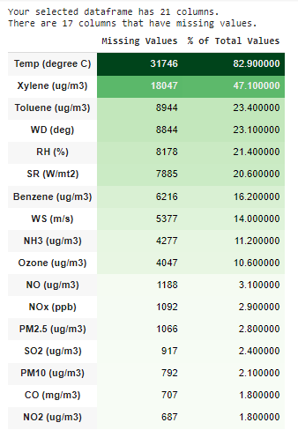

**Figure 5.1** Missing values

There is just 18% data is available for Temperature of each day which is not sufficient for ML algorithms to learn the impact of temperature on AQI. It is explained in a literature review, estimates are likely to be biased if more than 10% data is missing (Bennett, 2001).

# **5.1.1 Handling Missing Values**

Choosing the right method for handling missing values is essential. Based on my understanding about data I have chosen the following methods to fill missing values.

1. **Imputing missing values with mean**

As it is a time series data, so the temporal factors are used to execute this task.

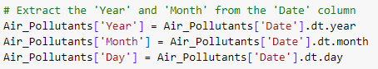

**Figure 5.2** Temporal Feature Extraction

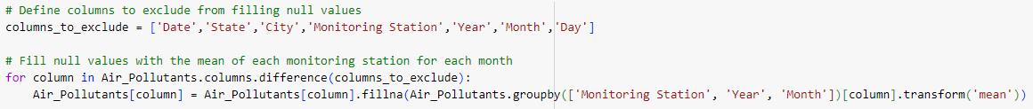

**Figure 5.3** Mean imputation

All the records are aggregated based on Monitoring station, year, and month. The mean of monthly records for each year is calculated as per the monitoring stations. Then the missing values are filled with the calculated mean for that specific year and month as per monitoring stations. For example, for monitoring station Golden Temple, Amritsar – PPCB the mean is calculated for January 2019. Then whatever the missing values are there for January 2019 for Golden Temple, Amritsar – PPCB are filled with this mean.

**Outcome:**

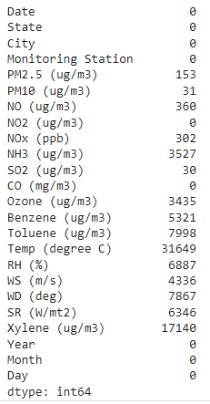

**Figure 5.4** Outcome ofMean imputation

Even after mean imputation some missing values are present in the data. To investigate this issue following action has been taken.

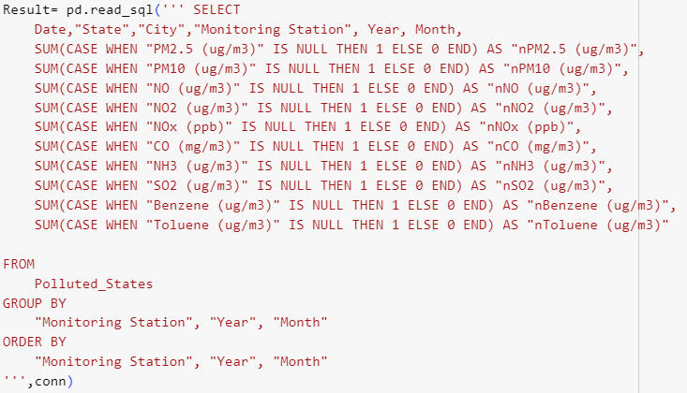

**Figure 5.5** Finding the count of missing value by year, month, and monitoring station.

The data frame is converted into a SQL table named Polluted States. A query is generated to calculate the number of missing values for each column for every month of each year as per monitoring stations.

**Outcome:**

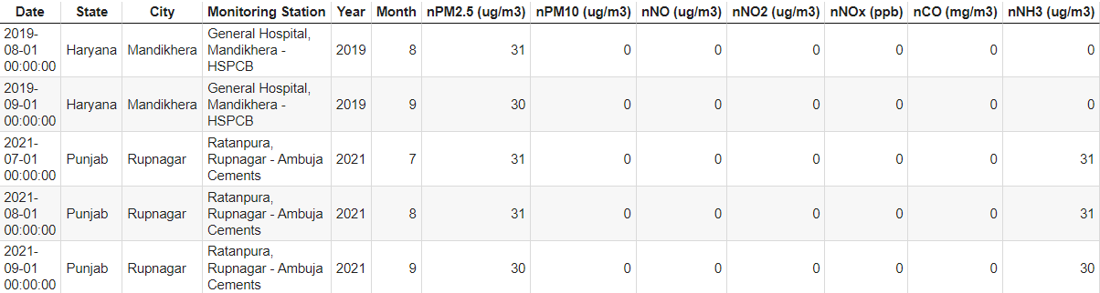

**Figure 5.6** Outcome ofSQL Query

After analysis, I found that for some stations where there are no records for the whole month. So, it is not possible to fill null values with mean. Now, there is another challenge to find another method for missing values imputation. Also, I make sure to meet the basic requirements to find AQI.

As, I explained before it is mandatory to have records of at least one of the pollutant matters (PM2.5 and PM10) and at least three out of the seven pollutants to find AQI. Because it is essential to have target variable ready to construct a predictive ML model. To do this following action has been taken.

1. **Filling remaining missing values with 0.**

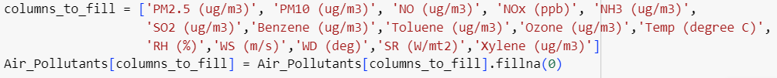

**Figure 5.7** Filling missing values with 0

All the remaining values are filled with 0 and the requirements are fulfilled to accurately find the AQI based on available ai pollutants.

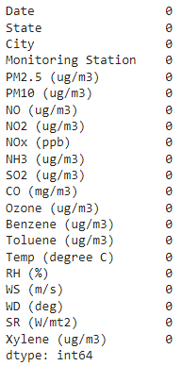

**Figure 5.8** Outcome of missing value imputation shown in Figure 5.7

Resultantly, dataset is free from missing values and ready to preprocess further. Based on the breakpoints of pollutants AQI is calculated. Now the prepared data will be used for other steps of preprocessing.

# **5.2 Correlation Matrix**

Correlation defines how data variables are dependent or can relate to one another. However, the statistical relationship between two variables is referred as a correlation. It is essential to find the relationship between variables to perform accurate feature selection.

A correlation could be described in three different ways.

**Positive Correlation:** When both variables change in the same direction.

**Neutral Correlation:** When no relationship in the change of the variables.

**Negative Correlation:** When variables change in opposite directions.

# **5.2.1 Pearson’s Correlation**

The Pearson correlation coefficient is used to summarize the strength of the linear relationship between the numerical variables in the dataset. In python it is done as follows.

**Air_Pollutants.corr()**

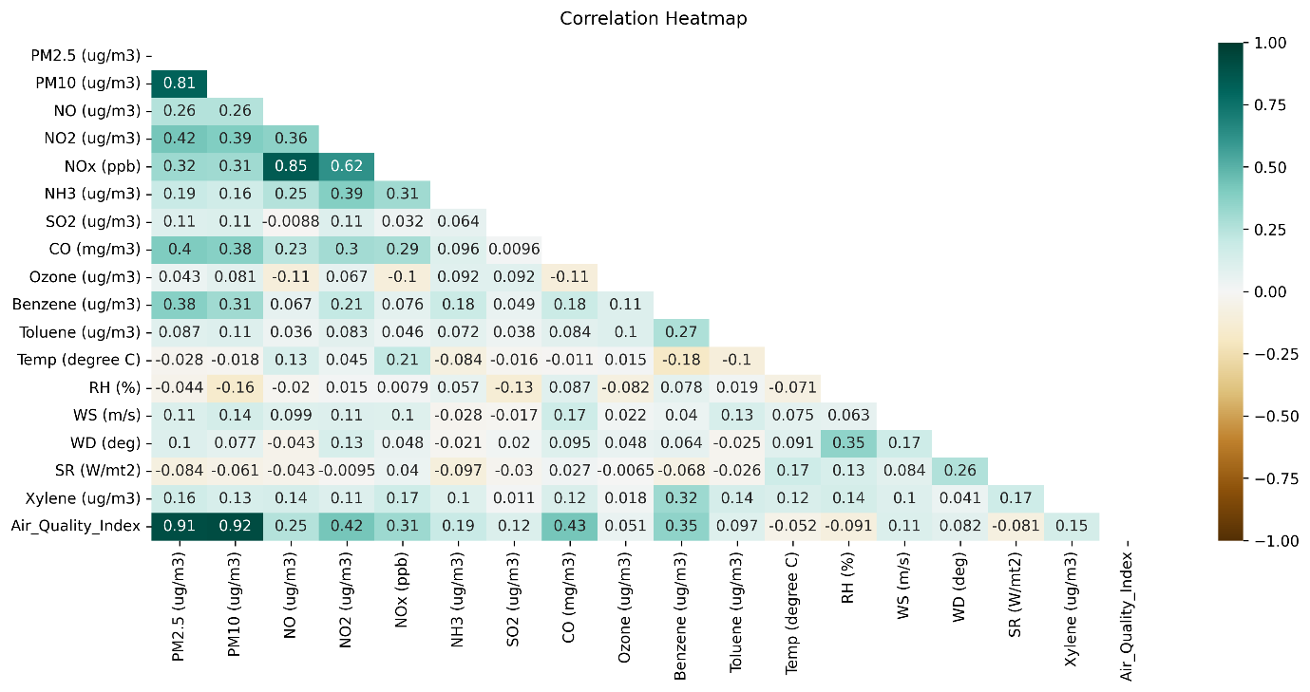

**Figure 5.9** Correlation Matrix

To interpret the correlation matrix easily, I sorted it in ascending order based on the correlation values between each variable and AQI(Air_Quality_Index). It is shown in **Figure 5.10**.

It is analysed that both the pollutant matter PM 2.5 and PM 10 have the highest positive correlation with AQI. However, the meteorological factors are least correlated, in fact Temperature, SR, and RH are negatively correlated with AQI.

There can be multiple reasons for such negative correlation. The main one can be the missingness of authentic data for all the meteorological factors. Whereas, in paper (Ravindiran et al., 2023) they have mentioned that they found that meteorological factor’s contribution in AQI prediction is almost negligible. On the other side, results of research paper (Guo and Feng, 2019) indicated that average T, RH, V, and WF scale are the principal factors that affect air quality. The variation in pollutant emissions affects an area within a hundred-kilometres radius from the source, it also depend on local meteorological and geomorphological conditions (Carnevale et al., 2018).

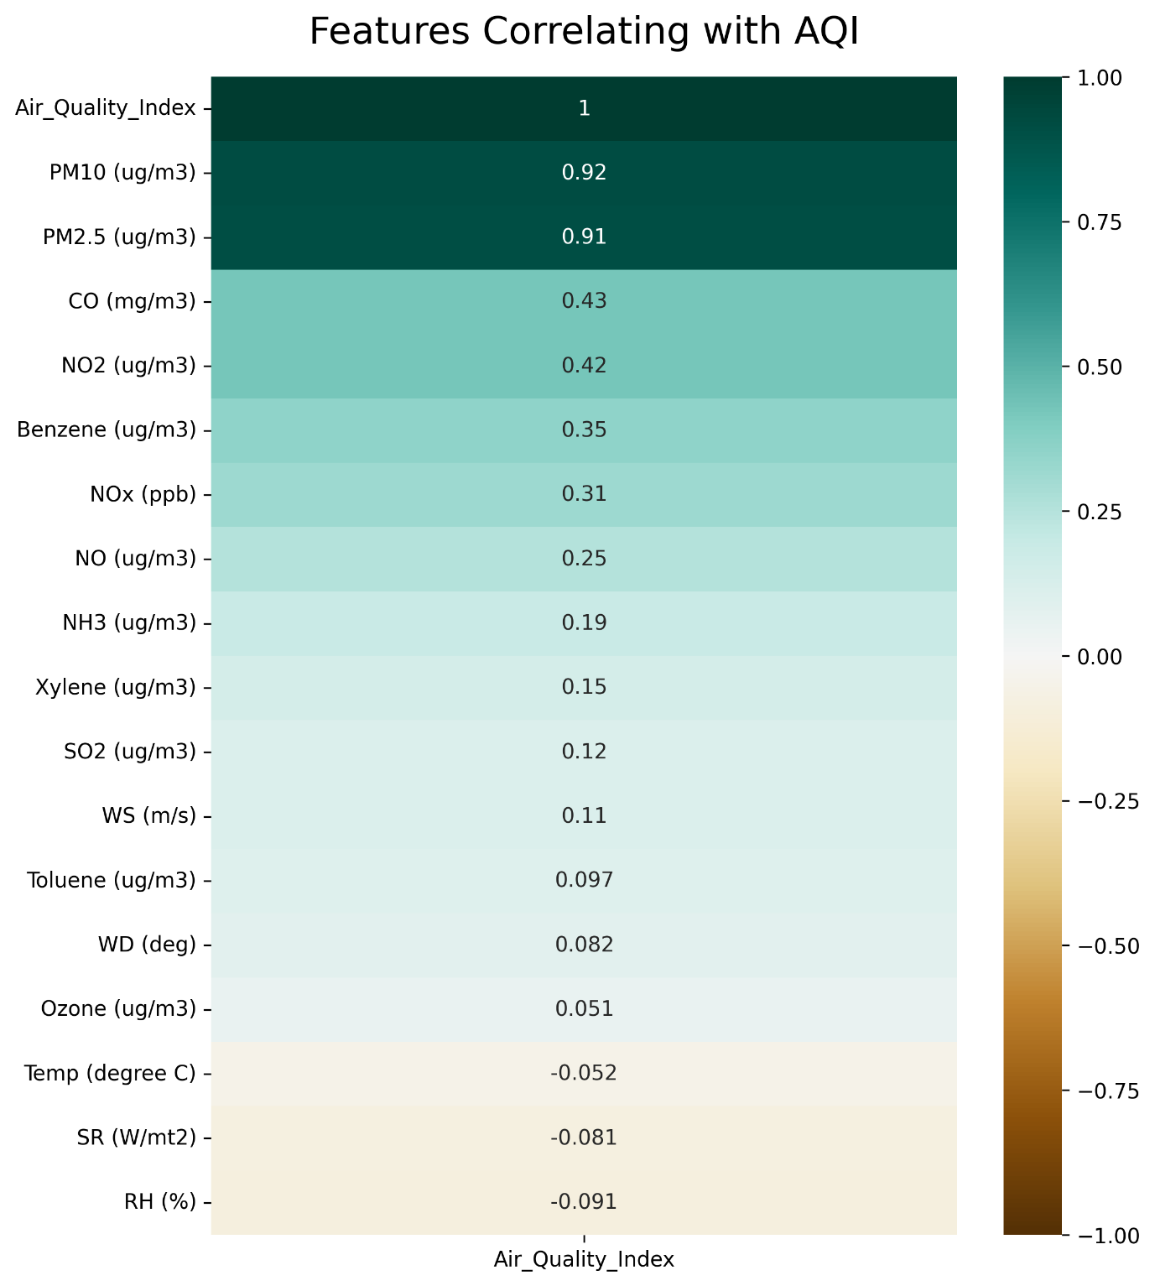

**Figure 5.10** Correlation Values in ascending order

Even Volatile Organic Compounds have week relationship with AQI. I believe, if there would be sufficient data available about Volatile Organic Compounds and meteorological factors these factors will be more correlated to AQI.

# **5.3 Feature Selection**

For this research it is not a good approach to consider variables with week correlation, also there is not sufficient and authentic information available about the concentration of these variables. So, the meteorological factors, Volatile Organic Compounds and Ozone is removed from the dataset.

# **5.4 Data Description**

Descriptive statistics of the dataset is shown in Figure 5.11.

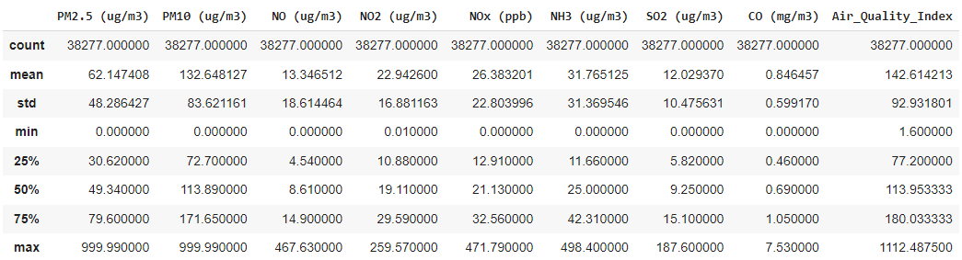

**Figure 5.11** Descriptive Statistics of the dataset

It is analysed, there is extreme gap not only between mean and the maximum value also in the 75% percentile for each variable. It might be due to the existence of outliers in the data. This statistical description showcases the need for further preprocessing.

# **5.4 Outliers**

There are chances that Air Pollution data may contain outliers. It means, the data points deviate significantly from other observations, indicating exceptionally good or poor air quality. It is a critical step to identify and understand extreme pollution episodes that can have serious environmental and public health consequences. Outliers can be caused by a variety of variables, including measurement mistakes, odd meteorological circumstances, and pollution occurrences.

# **5.4.1 Identifying Outliers**

For identifying the outliers in data, I used Tableau, and displayed it by Box Plots. Following from Figures 5.12 to 5.20 represents the outliers in PM 2.5, PM 10, NO, NO2, NOx, NH3, CO, SO2 and AQI.

A box plot helps to visualize the distribution of data for a continuous variable. It helps to visualize the centre and spread of data on a scale. Also, it can be used as a visual tool to check for normality, in this research it is used to identify points that may be outliers.

The extended lines from the box are called whiskers. The whiskers represent the expected variation of the data. The whiskers are the 1.5 times the IQR extension from the top and bottom of the box. If the data do not extend to the end of the whiskers, then the whiskers extend to the minimum and maximum data values. An outlier is more extreme than the expected variation. Further, these data points need to be reviewed to determine if they are outliers or errors; the whiskers will not include these outliers.

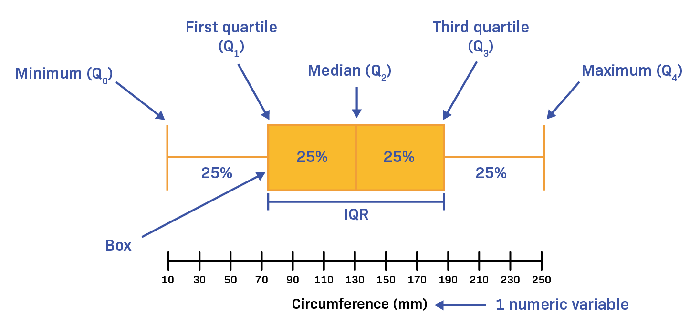

**Figure 5.12** Interpretation of Box Plot

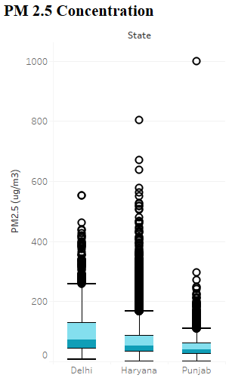 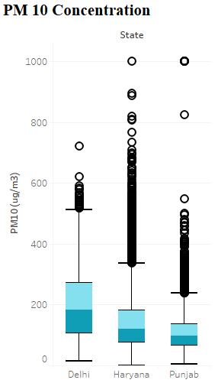

**Figure 5.13** Outliers in PM 2.5 Concentration **Figure 5.14** Outliers in PM 10 Concentration

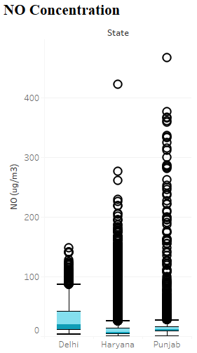 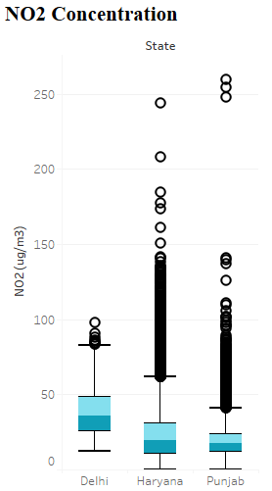

**Figure 5.15** Outliers in NO Concentration **Figure 5.16** Outliers in NO2 Concentration

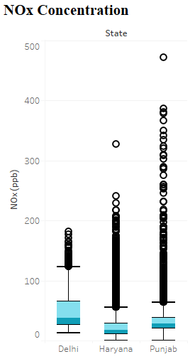 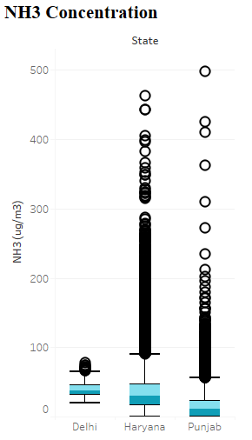

**Figure 5.17** Outliers in NOx Concentration **Figure 5.18** Outliers in NH3 Concentration

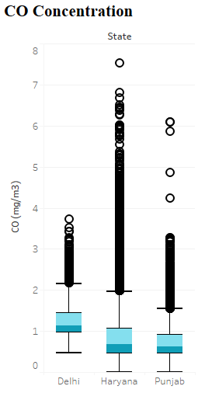 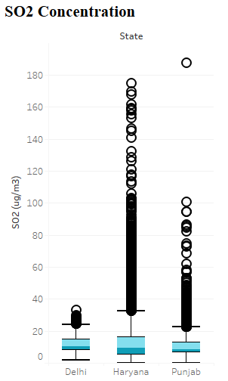

**Figure 5.19** Outliers in CO Concentration **Figure 5.20** Outliers in SO2 Concentration

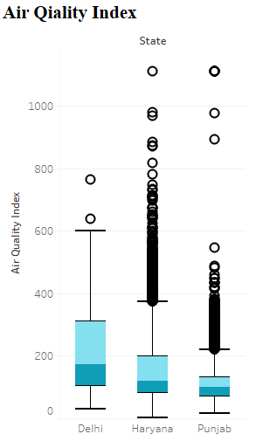

**Figure 5.21** Outliers in AQI Concentration

It can be analysed from the above box plots; each pollution concentration has outliers in the data. But on the basics of domain knowledge and data understanding all the dots cannot be considered as outliers. In experimentation, it is analysed that attempt to remove all the outliers leads to entire data loss. Thus, considering all the dots as outliers and deleting it is not a good approach.

Moreover, it is described in (Fernando, 2021) to simply remove the data point if it is considered as an outlier. However, from a regulatory point of view this is unacceptable, unless it is recorded and removed before any analysis has been carried out. A simple definition of an outlier is data “that appears not to belong among the other data present”.

# **5.4.2 Data Investigation for Outliers**

In this study the same patterns are noticed, where the data points appear far from the other data present. Even during investigation some scenarios are found to be unusual as compared to rest of the data. Some of these findings are shown in the following figures.

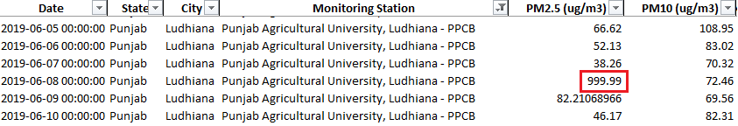

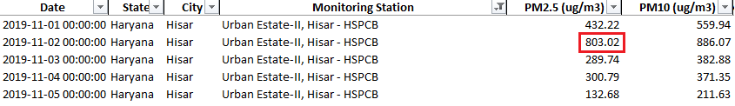

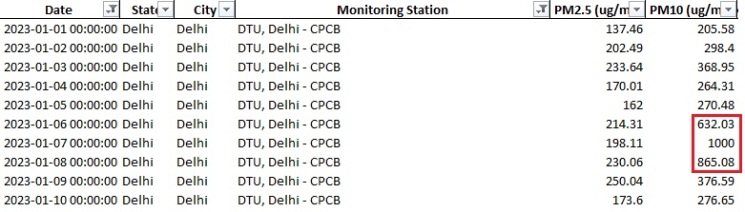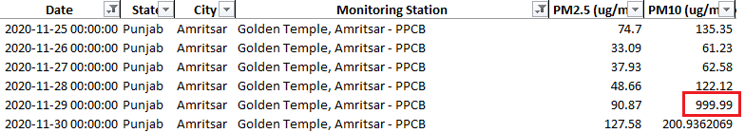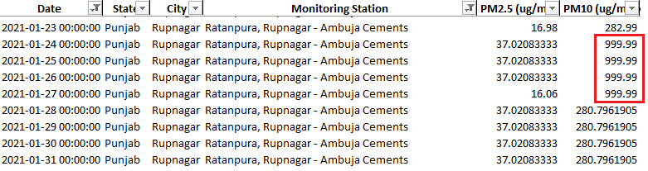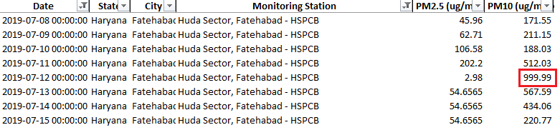

**Figure 5.22** Unusual Data Points

There are different scenarios that can cause such extreme variations in data like measurement errors, odd meteorological circumstances, and pollution occurrences.

# **5.4.3 Handling Outliers**

Handling the outliers in data is the most important step for accurate working of predictive ML models. Simply removing the outliers is not a good approach in this case, as it is found in experimentation that removing all the outliers leads to entire data loss. Moreover, it is a time series data and removing some records from it will result in frequency interruption.

All the data points that appear to be extremely deviated from the other data points are considered as outliers. It is handled by following two approaches.

* **Making the extreme values empty:**

These extreme values are made empty for each state individually, because each state appears different patterns of pollution concentration. The details of these data points are mentioned in below table. For each state whatever the values are more than mentioned in the table are considered as outliers.

|  |  |  |  |
| --- | --- | --- | --- |
| **State/ Air Pollutants** | **Delhi** | **Punjab** | **Haryana** |
| **PM2.5 (ug/m3)** | 550 | 300 | 600 |
| **PM10 (ug/m3)** | 700 | 500 | 700 |
| **NO (ug/m3)** | 130 | 270 | 210 |
| **NO2 (ug/m3)** | 100 | 145 | 145 |
| **NOx (ppb)** | 150 | 190 | 210 |
| **NH3 (ug/m3)** | 75 | 150 | 290 |
| **SO2 (ug/m3)** | 30 | 55 | 105 |
| **CO (mg/m3)** | 3.50 | 3.30 | 5.50 |

**Table 5.1** Outliers in Air Pollutants Concentration for each state

All the data point above these values are made empty (NaN) on basis of interpretation of shown box plots.

**Outcome:**

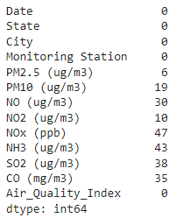

**Figure 5.23** The number of null values for outliers

* **Time Interpolation:**

A technique used to estimate the value of a function at an unknown point based on its known values at other points is known as Interpolation. Interpolation is necessary when data points are available at certain time intervals and need to estimate values at other time points within that range. In mathematical terms, it assumes a linear relationship between the known points and calculates intermediate values along a straight line.

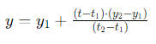

**Figure 5.24** Formula for Time Interpolation

**Outcome:**

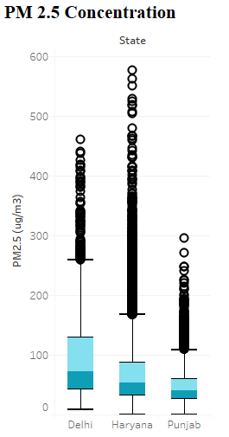 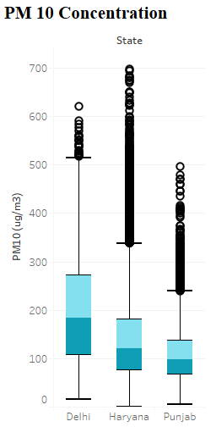

**Figure 5.25** PM 2.5 After handling Outliers **Figure 5.26** PM 10 After handling Outliers

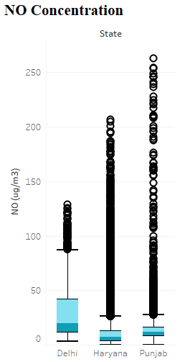 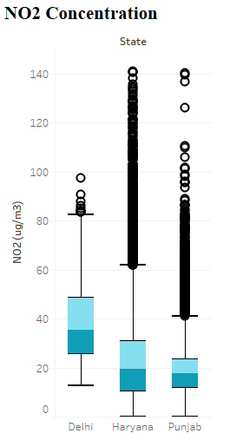

**Figure 5.27** NO After handling Outliers **Figure 5.28** NO2 After handling Outliers

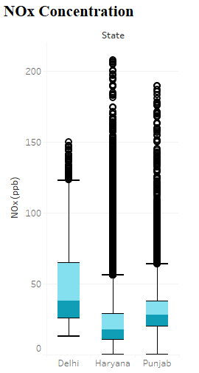 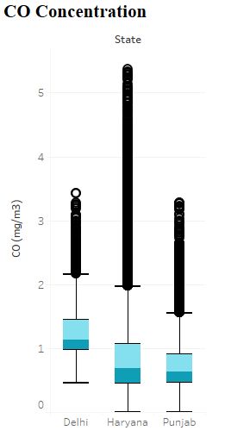

**Figure 5.29** NOx After handling Outliers **Figure 5.30** CO After handling Outliers

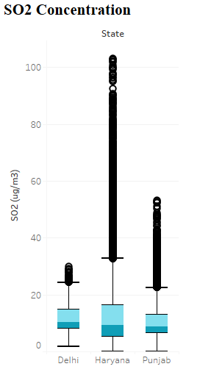 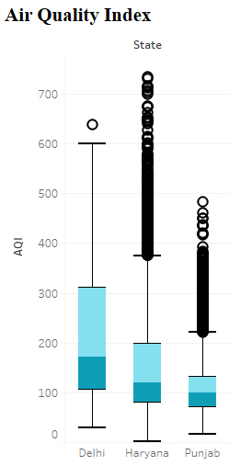

**Figure 5.31** SO2 After handling Outliers **Figure 5.32** AQI After handling Outliers

After time interpolation imputation all the extremely deviated data points are altered based on the nearest data points. For example,



The value for PM 2.5 on 2019-06-08 is altered as follows.

Y= 38.26 + ((2019−06−08) − (2019−06−07)) ⋅ (82.21−38.26) ​/ ((2019−06−09)−(2019−06−07))

Y= 38.26 + ((1) ⋅ (43.95)​) / (2)

Y= 38.26 + (43.95​) / 2

Y= 38.26+21.975

Y= 60.235

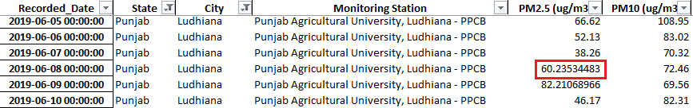  
**Figure 5.33** Output of Time Interpolation

# **5.5 Data Description after Outliers**

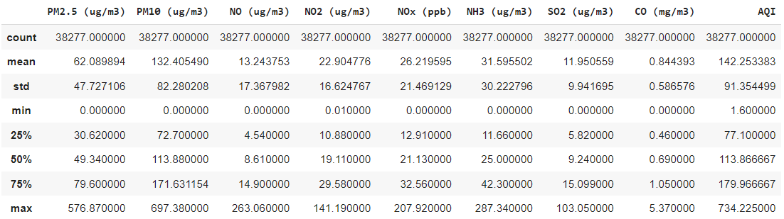

**Figure 5.34** Descriptive Statistics after Outliers

# **5.6 Feature Engineering**

All the preprocessing steps that transform raw data into features that can be used in predictive ML algorithms is defined as the feature engineering pipeline. Feature engineering consists of various steps like creation, transformation, extraction, and selection of features that are most essential for creating an accurate ML algorithm. In simple words, feature engineering is the act of transforming raw observations into desired features using statistical or ML approaches.

# **5.6.1 Feature engineering Techniques for ML**

There are few feature engineering techniques used in this research, which will work better with some ML algorithms or dataset, while other may be useful for all the situations.

* **Imputation:**

Missing values is the most typical issue that occur, at the first stage, while preparing the data for ML algorithms. There can be multiple reasons for such missing values as mentioned earlier. The main goal of imputation is to handle missing values accurately.

* **Handling Outliers:**

Outlier handling is a technique, which focuses on handling the extremely deviated data points from other data points.

* **One-Hot Encoding:**

In this research binary encoding scheme is used, which converts the columns into 0 or 1. A specific variable which is true for a record will be marked as 1, however rest of the variable of same category will be marked 0. Overall, this scheme assigns a unique value for each possible case.

In this research one-hot encoding is applied spatial variables like state and city. Because variable having data type ‘Object’ cannot be included in ML algorithms. However, another variable Monitoring Stations has not been considered due to high volume of values. Because adding too many columns in a dataset impacts model’s performance while training and testing a large dataset. But excluding Monitoring Station column will not result as a data loss, because each city has only Monitoring station. So, including city will be enough to make a record unique.

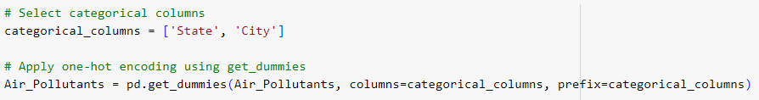

**Figure 5.35** One Hot Encoding for Spatial Columns

**Outcome:**

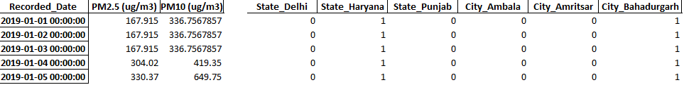

**Figure 5.36** One Hot Encoding Output

A sample of output has been attached displaying the date when data is recorded, followed by some Air Pollutants concentration, and encoded state and city columns. It clarifies that these five records are recorded at a monitoring station in city Bahadurgarh and state Haryana. It will help ML models to learn and predict while considering spatial features as well.

* **Scaling:**

The process of normalizing the range of features in a dataset refers to feature scaling. The features of dataset used in this research vary as per units. Therefore, for ML models to interpret these features on the same scale, there is need to perform feature scaling. In this research Standard scaling is used for this task.

# **6. Methodology**

# **6.1 Literature Review**

For this research I have chosen Literature review, Experimentation, and visualization to answer the research questions. This literature review is the base of this study. I carefully studied the outcomes and future scope of all the literature related to this study, to find the research gap. Based on reviews I implemented different algorithms to predict AQI. Moreover, I analysed the data and processed it using my data analyst and data scientist skills. To ensure the accuracy of literature review following things were considered.

* Identified keywords which are mainly related to this thesis like AQI, forecasting, prediction, ML algorithms, Time series algorithms, ML, Particulate matter, Gaseous pollutants, Meteorological parameters, Climate action, air pollution, SARIMAX, LSTM, Holt-Winter's, Dickey-Fuller Test, Mean Absolute Percentage Error etcetera.
* Searched for literature review using these keywords at platforms like ResearchGate, Google Scholar, IEEE, Science Direct, PMC PubMed Central etcetera.
* Important research works were filtered by considering inclusion criteria and exclusion criteria.

# **6.1.1 Inclusion criteria:**

* Included studies that are related to both prediction of AQI and machine learning.
* Only published papers are included.
* The number of citations on that paper are considered.

# **6.1.2 Exclusion criteria:**

* Research papers which are not scientific are excluded.
* Research papers which don’t follow proper guidelines like without having abstract are excluded.

# **6.2 Visualization**

This research focuses on three major states Delhi, Punjab, and Haryana, which are the neighbouring states. As compared to other two states Delhi is more polluted, maybe because it is the capital of India. Millions of people travel from one place to other place and the pollution from the busiest airport on India known as Indra Gandhi International Airport impacts a lot on the AQI of Delhi. The area covered in this research has been shown on Indian map in below picture.

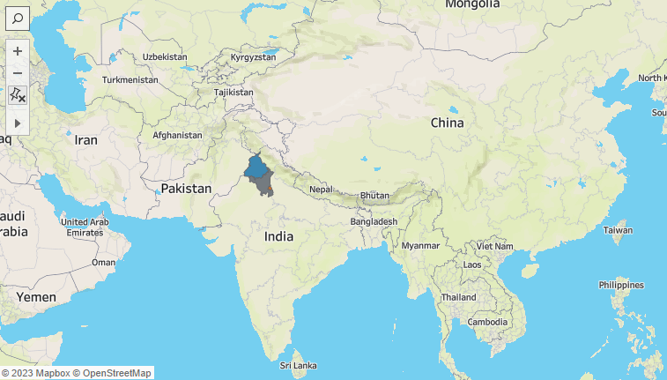

**Figure 6.1** Research Area on Map

This research is focused on states in Northern part of India. Further, the different monitoring stations included in this research are shown revealing the concentration of AQI during the last peak period, November 2022.

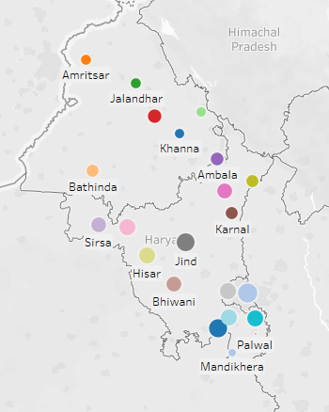

**Figure 6.2** Different cities where Monitoring Stations are located on Map.

In total the dataset from 22 different monitoring stations has been used. But due to limitations of Tableau names are not appearing for every state.

In different papers like (Govardhan et al., 2023) (Das et al., 2023) (Abdurrahman et al., 2020) they have mentioned about the stubble burning activities in Punjab and Haryana and its impact on other neighbouring countries especially Delhi. During the peak period mainly November, it is believed that stubble burning and smoke generated in Punjab and Haryana is responsible for the bad air quality of Delhi. The EDA conducted in this research focus on finding any interesting patterns or facts to make relation between these connecting dots mentioned in these research papers.

There are two major seasons of stubble burning one from Middle of March to May and the other major one from Middle of October to End of November each year.



**Figure 6.3** Before and duringBurning period from March to May.



**Figure 6.4** Before and duringBurning period from September to November.

A huge difference can be seen in the fire activities before and during the stubble burning period. It is more serious issue in Punjab and Haryana(North of this map) as compared to other states.

# **6.2.1 Impact of COVID-19 on burning activities:**

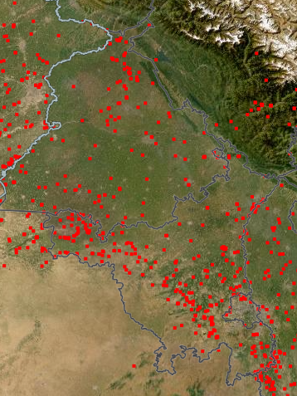 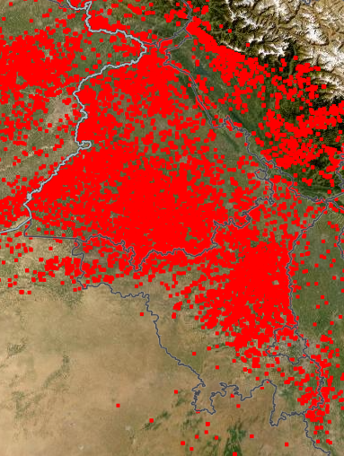

Source:(“NASA-FIRMS,” n.d.)

**Figure 6.5** PunjabApril 2020 **Figure 6.6** PunjabApril 2022

A significant difference in the fire activities is visible on the map, majority of the fires will be related to stubble burning during this period. However, with the passage of time things come to normal.

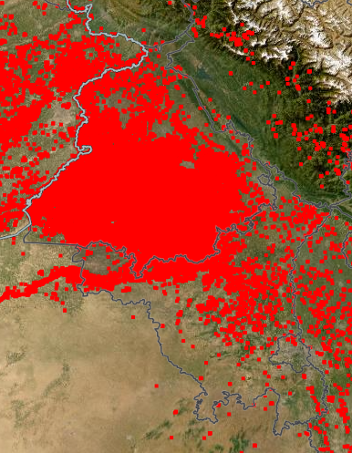 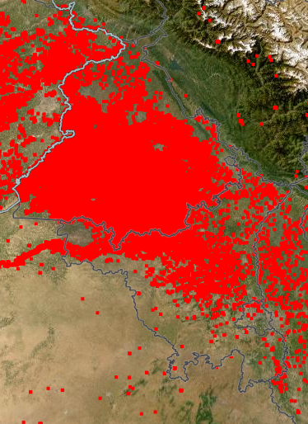

**Figure 6.7** PunjabNovember 2020 **Figure 6.8** PunjabNovember 2022

As a result, stubble burning kept on going as normal during the major peak period in COVID year.

Further, to verify the concentration of AQI in these three states individually a head map has been created in Tableau.

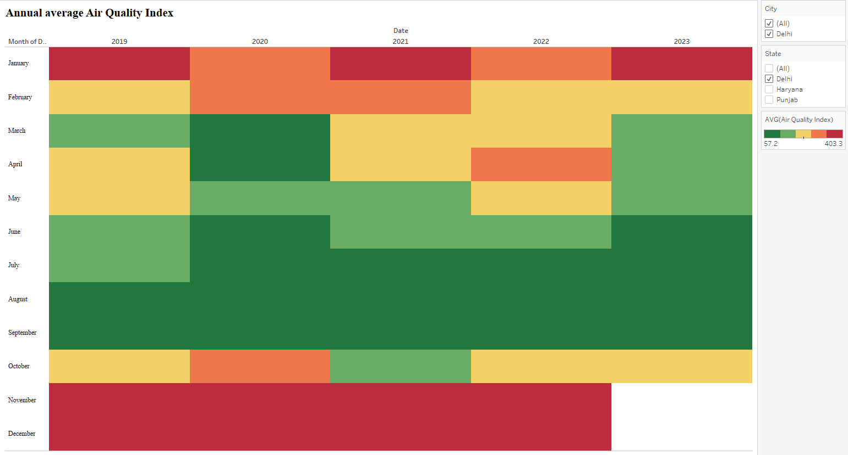

**Figure 6.9** Heatmap of monthly average AQI in Delhi from 2019-2023

It is clear from the heatmap, AQI was at its peak during November and December, even in COVID year. However, during immediate COVID period AQI was at its lower and a similar pattern has been noticed in year 2023.

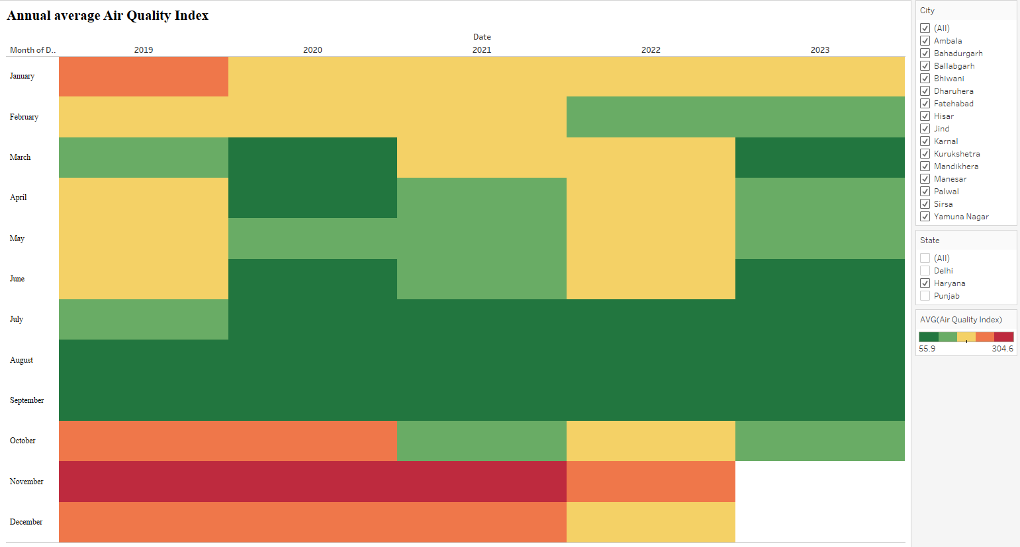

**Figure 6.10** Heatmap of monthly average AQI in Haryana from 2019-2023

As compared to Delhi, in Haryana the AQI is lower during January, October and December in all the years. Whereas, the high AQI is clearly visible during peak period.

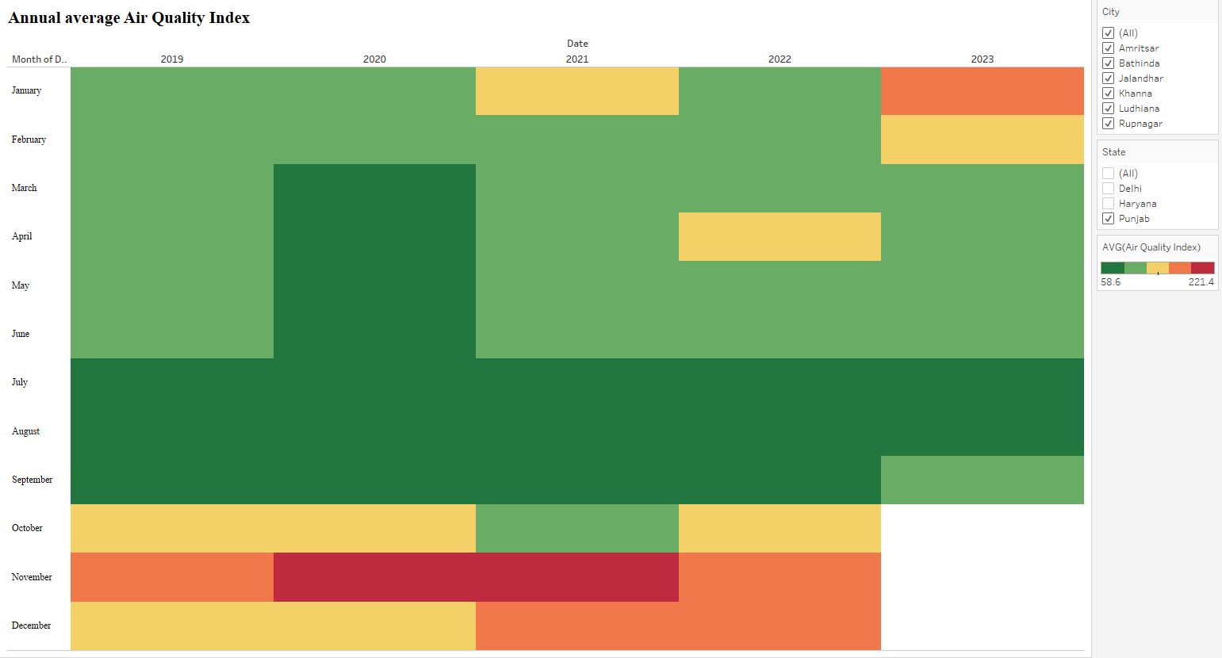

**Figure 6.11** Heatmap of monthly average AQI in Punjab from 2019-2023

As compared to Delhi and Haryana, Air quality of Punjab is healthier to survive.

# **6.2.2 Seasonality and Relation between different air pollutants concentration and AQI.**

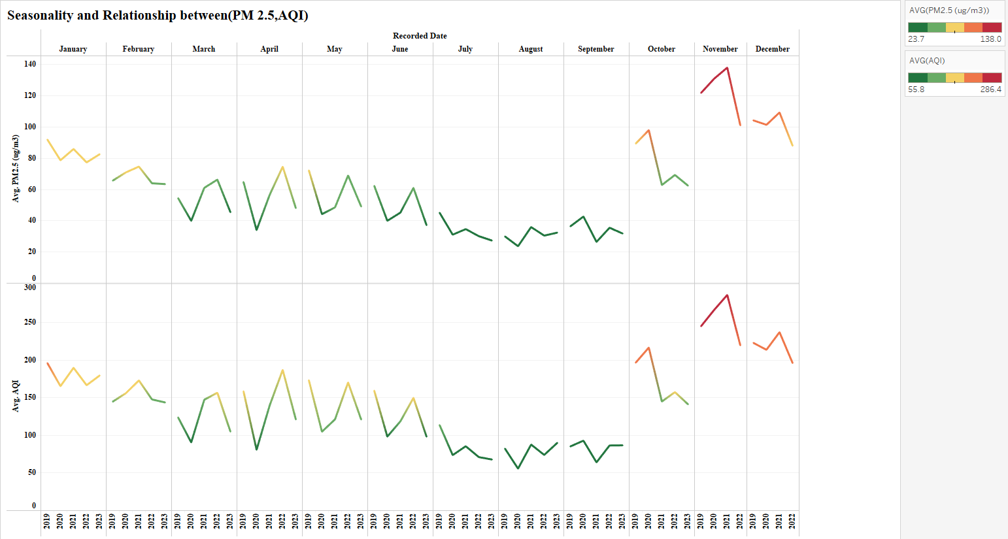

**Figure 6.12** PM 2.5/ AQI

**Note:** Kindly zoom the figure for a clear view.

The purpose of this graph is to show, the relation between PM 2.5 and AQI, as both the measures change in the same way and at same time during the year. Whenever the concentration of PM 2.5 increase in the air, the AQI automatically increases the same way and vice versa. Both PM 2..5 and AQI has a peak period of almost three months from October to December each year.

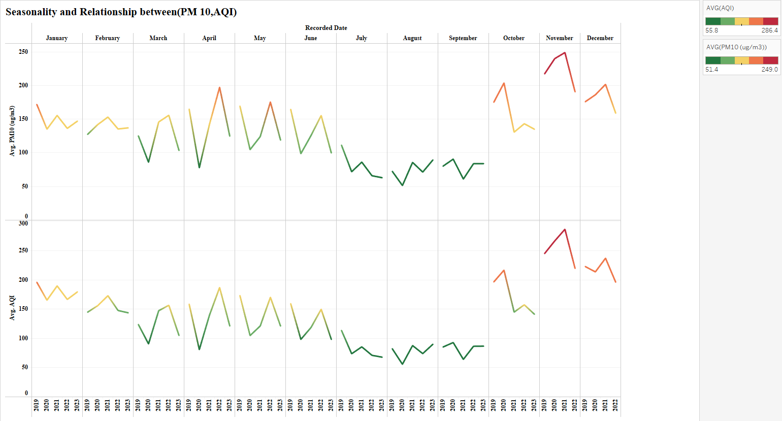

**Figure 6.13** PM10/AQI

The same way it changes for PM 10 as well. Even, the steps of upward or downward trends are same. Thus, the air pollutants taken into consideration for this research are highly correlated with AQI. So a control or at least a careful life style should be opted to be healthier in this deadly air.

# **6.3 Experimentation**

In this research, the root of experimentation is literature review. The dataset collection, preprocessing steps, ML models, Time Series Models and Deep Learning models are carefully reviewed form different research papers. Each paper has been reviewed and understood to find insights they already got from similar research topic. Moreover, the future scope has been analysed to search for research gap and improve the models based on domain understanding.

Experimentation is a combination of multiple steps like data collection, preprocessing, testing, and training of various ML models, SARIMAX and LSTM model. Further, the performance of applied models has been analysed.

# **6.3.1 Data Split**

As it is a time series data, so the test train data has been split by date rather than percentage or ratio like (80% test, 20% split). However, even based on date it is approximately divided into 4 years for training and approximately one year for testing. For example, from 01-01-2019 to 01-10-2022 is the training data, and remaining from 01-10-2022 to 15-10-2023 is taken as testing data.

AQI is the target variable (dependent) which is predicted based on other air pollutants(Independent) variables.

# **6.3.2 Machine Learning Models**

# **CatBoost:**

CatBoost is a newly developed open-source ML model. It is introduced in 2017 by Yandex, which is a Russian counterpart to Google, working within search and information services (“Yandex”). One of CatBoost’s speciality is its ability to integrate a variety of different data types, such as images, audio, or text features into one framework.

However, basically it is built upon the theory of decision trees and gradient boosting. The main purpose of boosting is to sequentially combine many weak models and thus through greedy search create a strong competitive predictive model. In the growing procedure of the decision trees, CatBoost follows a different approach than gradient boosting models. As, CatBoost grows oblivious trees which means, the trees are grown by imposing the rule that all nodes are at the same level, test the same predictor with the same condition, and hence an index of a leaf can be calculated with bitwise operations.

An inconsistent arrangement of gradient learning information is used to improve the implementation of the CatBoost algorithm and to avoid overfitting. An explanation of the CatBoost algorithm is shown in Figure 6.1. The training ability of CatBoost algorithm is managed by its framework hyperparameters, like iterations number, rate of learning, maximum depth etcetera.

# **1.1 Hyper Parameters for CatBoost**

Research papers (Filho, 2023) explains about the hypertuning for CatBoost algorithm. He mentioned about some main parameters to focus on during the process of CatBoost hypertuning. Iterations, learning_rate, depth, subsample, colsample_bylevel, and min_data_in_leaf. However, the parameters considered in this research are listed below.

**Iterations:** The number of steps the algorithm takes to create a more accurate model that learns from the data. However, the best value for the number of iterations depends on your specific problem. Keeping the iterations to a lower number is good step for optimization.

**learning_rate:** It scales the contribution of each decision tree to manage the balance and accuracy of the model.

**depth:** It refers to the height of decision tree. It is used to control over-fitting.

However, in this research 'depth': [3, 6, 8], 'learning_rate': [0.01, 0.05, 0.1], 'iterations': [100, 300, 500], 'loss_function':['RMSE'], and 'random_seed':[42] are considered.

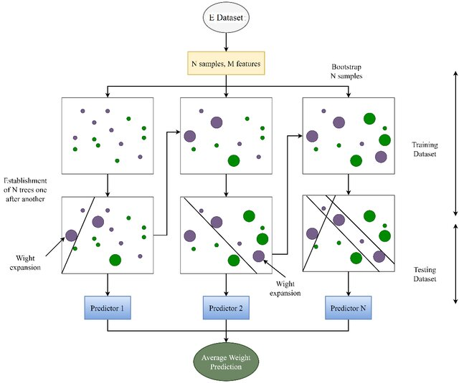

Source: (Shahani et al., 2022)

**Figure 6.14** Explanation of the CatBoost algorithm

# **XGBoost:**

XGBoost is one of the important types of ensemble learning algorithm in ML approaches (Meng et al., 2016). A technique for combining numerous weak classifiers into a single effective one is known as boosting. It is mentioned in (Mahesh et al., 2022), the basis step for the development of XGBoost is applying Gradient Boosting. XGBoost variation of Gradient Boosting outperforms the original in terms of computing efficiency, scalability, and generalisation performance. The most important thing to keep in mind is, data organization while using XGBoost. XGBoost only takes numeric vectors as an input so transforming categorical data into their numerical equivalent is important before using the model. Considering this point the spatial variables like State and city are converted into numerical version using One-Hot Encoding. Further, feature engineering and data purification needs to be applied for best performance.

To enhance the framework performance, the boosting method construct diverse trees and sequentially refine the predictions by considering residuals from historical trees. A gradient descent approach is employed during the loss function reduction stage, to progressively improve predictions by adding supplementary trees at each stage. When tree reaches to a predetermined number or when training stage error cannot be further reduced to the expected sequential tree count it results as a halt for further tree development. For symmetric trees, a random subsample without replacement is used for training, enhancing the adaptability of the tree, and forming an improved framework.

The general structure of XGBoost is shown in Figure 6.2.

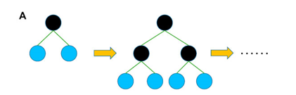

Source: (Shahani et al., 2021)

**Figure 6.15** Basic structure of the level-wise XGBoost tree model.

# **Hyper Parameters for XGBoost**

Same parameters as of CatBoost model are considered for XGBoost. The above-mentioned parameters work in the same way. For this model 'depth': [3, 6, 8], 'learning_rate': [0.01, 0.05, 0.1], 'iterations': [100, 300, 500] and 'random_seed':[42] is passed for the GridSearchCV.

# **Random Forest Regressor:**

RF is a type of ensemble ML algorithm proposed by Breiman in 2001 (Breiman, 2001). A combination of bagging and random subspace approaches is the foundation of RF. It involves the process of creating an ensemble method that is used to merge these trees into a single forecast based on the bagging of numerous learning trees, where N examples from the training set (D) are used to form bootstrap samples (Db) of n random instances. These bootstrap samples are used to build K different regression trees. The random forest prediction is made by averaging K predictions from regression trees hk (x).

The schematic diagram of random forest regression (RFR) is shown in Figure 6.3.

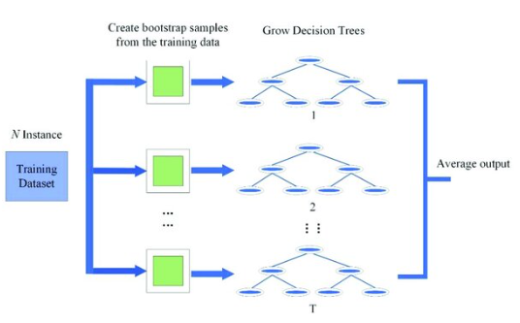

Source: (Liu et al., 2019)

**Figure 6.16** The schematic diagram of RFR

# **Hyper Parameters for Random Forest Regressor**

The main parameters for RFR are n_estimators, max_features and max_depth.

**n_estimators:** The number of trees in the forest.

**max_features: The** maximum number of features considered for splitting a node.

For this task 'n_estimators': [100, 200, 500], 'max_depth': [3, 6, 8], 'max_features': ['auto', 'sqrt', 'log2'], and 'random_state': [42] is passed for the tuning of RFR.

# **Support Vector Regressor:**

Support Vactor Regressor is a type of supervised ML model proposed by (Vapnik et al., 1996) in 1997. In SVR, the training data consists of predictor variables and observed response. The main goal of SVM is to find a function f(x) that deviates from yn (sample labels) by a value no greater than bias for each training point x that is, remain as flat as possible. Thus, SVM is also known as Tube regression.

The kernel functions used in SVR, including linear, polynomial, radial basis, and sigmoid functions, facilitate this process. An optimal hyperplane is employed for SVM which minimizes the distance from all data points, effectively approximating the training points and minimizing prediction errors. It is mentioned in (Ergun et al., 2010), the choice of kernel functions and their parameters significantly affects model accuracy. Methods like grid search using cross-validation approaches is an optimal approach to determine the optimal values for these parameters. Resultantly, it offers the highest cross-validation accuracy, ensuring robust and effective SVR modeling. The schematic diagram of SVM is shown in Figure 6.4.

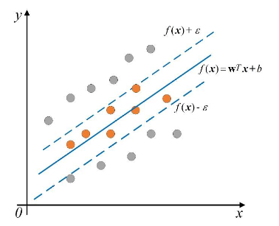

Source: (Liu et al., 2019)

**Figure 6.17** The schematic diagram of SVM

# **Hyper Parameters for Support Vector Regression**

There are three main parameters to consider while using the regression model.

**Kernal:** It is used to transform the data into required form. For example, linear, nonlinear, polynomial, radial basis function (RBF), and sigmoid. The default is rbf.

**Gamma:** It gives information about how much will be the influence of the individual data points on the decision boundary.

**C:** A hyperplane that maximizes the margin, as it tends to generalize better on unseen data. Whereas, it is important to keep in mind, setting C too small can lead to underfitting, where the model fails to capture the underlying patterns in the data.

For this model kernel='rbf', C=100, epsilon=0.1 are considered.

# **6.3.3 Time Series Model**

# **SARIMAX**

The equation of SARIMAX consists of part of equations from various other models such as AR model, MA model (for both seasonal and non-seasonal details).

AR models predicts future values based on historical records. This is used only when there is a correlation between the time series values and their preceding and succeeding values.

MA model uses past forecast errors in a regression-like model rather than using past values of the forecast variable. However, moving average models should not be confused with the moving average smoothing. A moving average model is used for forecasting future values.

ARIMA model stands for Autoregressive Integrated Moving Average. This model is highly efficient in handling various standard temporal structures present in time series data.

Overall SARIMAX model stands for Seasonal Autoregressive Integrated Moving Average or Seasonal ARIMA belongs to the family of the ARIMA model. It is mentioned in (Arora and Solanki, 2020), SARIMAX model is capable to handle a time series data that has a single variable along with seasonality. Apart from the hyperparameters for ARIMA, three different hyperparameters namely the

AutoRegression (AR), Integrated (I) and Moving Average (MA) for the seasonal part of the series along with one parameter for the period of the seasonality. Just adding X (an exogenous variable) in SARIMA model makes it SARIMAX.

# **Configuring the SARIMA Model**

The SARIMA model comprises of two significant elements known as Trend and Seasonal whose hyperparameters are to be selected to configure the SARIMA model.

* 1. **TREND elements:**

**p:** Trend based autoregression order.

**d:** Trend based difference order.

**q:** Trend based moving average order.

* 1. **SEASONAL elements:**

**P:** Seasonal based autoregressive order.

**D:** Seasonal based difference order.

**Q:** Seasonal based moving average order.

**m:** The count of time units for a single season (or a seasonal period).

# **Use of SARIMAX**

In this research paper the different air pollutants data is used from three different states having multiple cities and monitoring stations in it. In research paper (Arora and Solanki, 2020) they have used SARIMAX to predict NO2 for Faridabad and Delhi city based on six years of records. But at one time it was used to predict for just one air pollutant for just one city. In the same way SARIMAX model cannot be applied to predict AQI for all these monitoring stations at once. At one time it can predict for one station only. As I am working on a huge data, so it is not possible to predict for each monitoring station using SARIMAX. So, I have chosen the most polluted city, which is the capital of India known as Delhi to predict for AQI. A separate data frame of Delhi air pollutants concentration during the same time frame has been created from the original dataset used for this research. As explained earlier SARIMAX is used when there is seasonality in the data. So, the dataset of Delhi state has been checked for seasonality and it is shown in figure below.

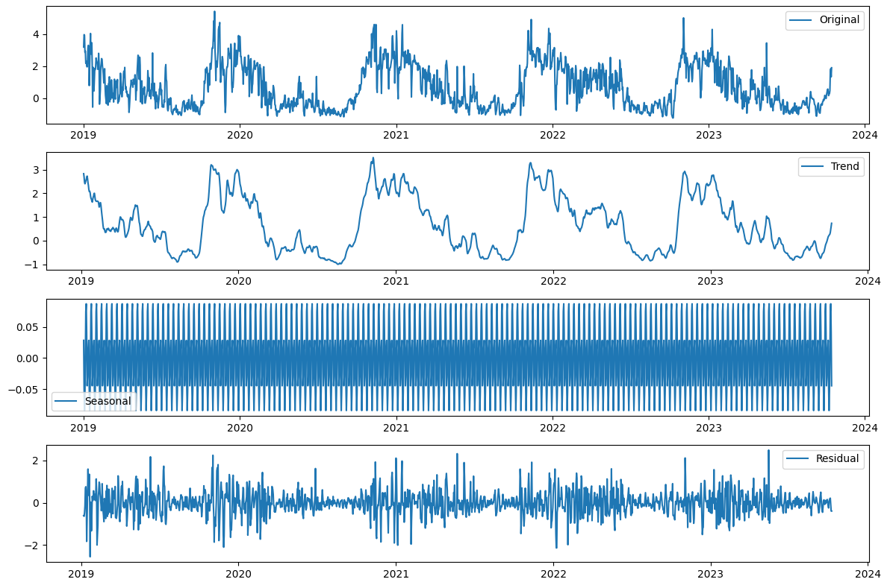

**Figure 6.18** Seasonality components of Delhi AQI dataset

It can be noticed, there is seasonality in the dataset. It the figure reveals that during the fourth quarter of each year the concentration of AQI was higher as compared to rest of the time. In other words, Delhi’s air pollution peaks during the winter months starting with Diwali (festival when excessive fireworks are used) and post-harvest agricultural waste burning and deteriorates further with lower surface temperatures resulting in an increase in demand for space heating (Cusworth et al., 2018) (Chowdhury et al., 2019) (Singh et al., 2019).

# **Testing for SARIMA Model configuration**

Before applying SARIMAX model different tests are used to analyse the dataset and ensure the model is trained accurately.

# **The Dickey-Fuller test**

The Dickey-Fuller test is used check if the AR model has unit root (null hypothesis) and if the data has seasonality or trend-seasonality(alternate-hypothesis), mainly it is used to determine whether the data is stationary or non-stationary.

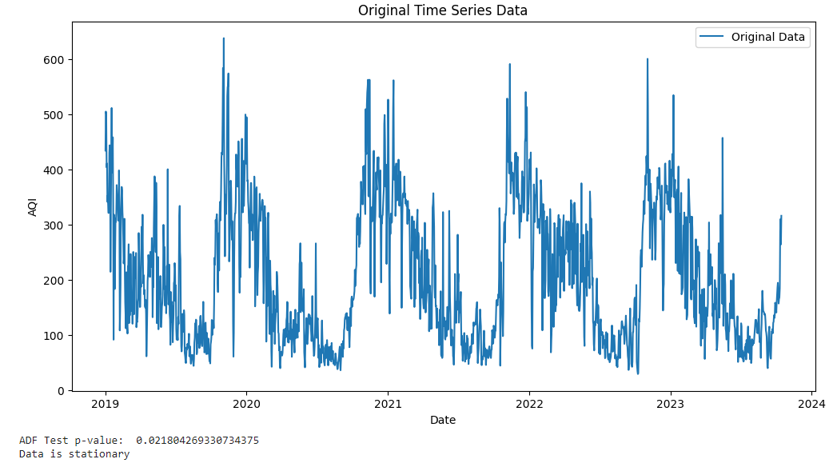

**Figure 6.19** The Dickey-Fuller test

The test results show that data is stationary. So, no further experimentation is needed for the dataset. As there are multiple records for same day, showing air pollutants concentration for different monitoring station that is why graph has multiple lines at back. Otherwise, the visualization is correct.

To choose the right SARIMAX hyper-parameters let’s plot the Autocorrelation and partial autocorrelation function plots. ACF and PACF help to identify the lags that have high correlations.

# **ACF**

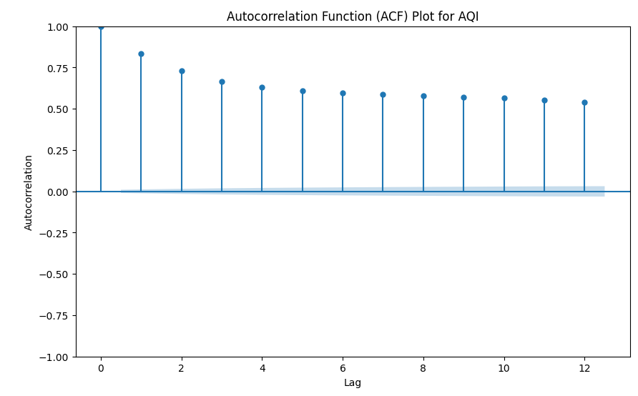

**Figure 6.20** ACF

It is already clear that the time series are seasonal and ACF plot confirms this pattern. However, by plotting more lags it can be observed if the significance of the lags is gradually declining.

It can be analysed that the highest lag is 1 followed by a gradual decline till 4 and remain constant till 12. It has clearly observed the peak period from last three to four months October, November, December. In the same way it reflected a peak in initial the initial three to four months.

# **PACF**

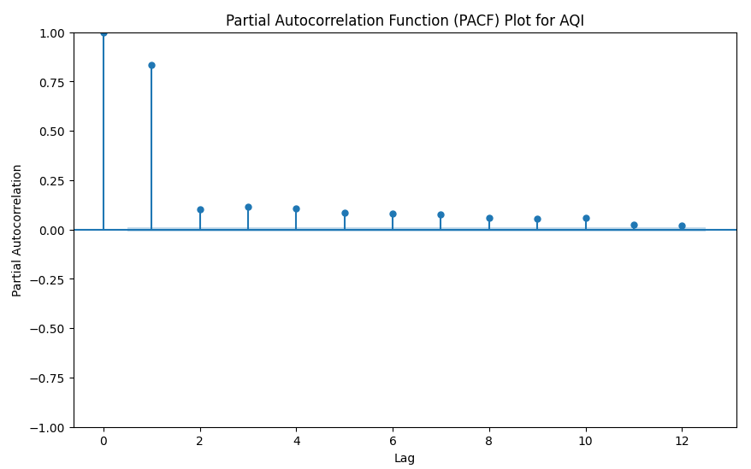

**Figure 6.21** PACF

The lag at 1 is the highest among all other. However, reast all the last are even below 0.05.

# **6.3.4 Deep Learning Model**

# **LSTM**

LSTM belongs to the category of Recurrent Neural Networks (RNN). The main feature of LSTM is its ability to maintain the state of the memory even after a long time due to the presence of the memory cell. The memory state consists of gates that regulate data flow in memory. The memory state is present in all LSTM cells to modify the information values of the previous states based on the importance of the gate units.

LSTM model consists of three important layers known as Input layer, Recurrent layer, and Output layer respectively. The output layer is connected to the three gates of the cell (input, output, and forget gates), and finally, the output layer (Ayturan et al., 2018). The memory cell of LSTM is shown in Figure 6.5.

LSTMs are explicitly designed to avoid the long-term dependency problem. Its capable for remembering information for long periods of time instead of struggling to learn something.

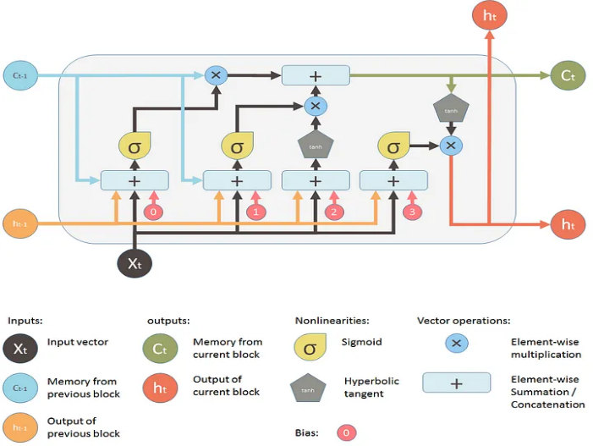

Source: (“Understanding LSTM Networks -- Colah’s blog”)

**Figure 6.22** The memory cell of LSTM

# **1.1 Important Hyperparameters for LSTM**

**Batch Size:** It defines the number of samples to work on before the internal parameters of the model are updated. Large sizes make large gradient steps compared to smaller ones for the same number of samples “seen”.It is generally accepted that a good default value for batch size is 32. However, for experimentation, you can try multiples of 32, such as 64, 128 and 256.

**Epoch:** It is the process of going through all your training samples once, where one iteration/step refers to training over a single minibatch. For example, If the training sample are 1,000,000 and batch size 100 is used, then one epoch will be equivalent to 10,000 steps, with 100 samples per step (Nanthak, 2020) (bsquare, 2020).

**Loss Function**: It is used to calculate the loss, which is the difference between the predicted value and the actual value. Further, Mean Square Error has been set to calculate the loos while using LSTM model.

**Optimiser:** It plays a very crucial role to increasing the accuracy and overall performance of the model. There are many optimiser variants that can be used like SGD: Stochastic Gradient Descent, Nesterov accelerated gradient, Adagrad, AdaDelta, RMSProp, Adam. In paper (purutheguru, 2016) it is stated, RMSProp, AdaDelta and Adam are very similar algorithms. However, Adam was found to slightly outperform RMSProp, Adam is generally chosen as the best overall choice.

# **1.2 Hyperparameters used in this research**

Batch Size: 32, Epoch: 50, Loss Function: Mean Square Error, Optimiser: Adam

After some steps of experimentation, I got the above value as the best performers for LSTM. However, more experimentation can be done to find the optimal hyperparameters, due to lack of computational power I am unable to try multiple options especially the epochs. For this dataset the given values worked well.

# **7 Results**

# **7.1 Experimentation Outcome**

This section shows the analysis of experiments with the proposed dataset collected from CPCB official website. For experimentation purpose, PM2.5 (ug/m3), PM10 (ug/m3), NO (ug/m3), NO2 (ug/m3), NOx (ppb), NH3 (ug/m3), SO2 (ug/m3), CO (mg/m3) attributes are considered as an input to obtain the AQI attribute which is the final output. The theoretical analysis from different literatures is prioritized to select the ML models, Time series Model and Deep Learning model to predict AQI. Same collection of data has been used for all the models except the time series SARIMAX. The reason behind it is that I am using data for different states, cities, and monitoring stations for a single day. Meaning I want to predict for all the major air polluted states especially those are interrelated to each related due to excessive stubble burning activities. In this case it is important to predict for all the related states to this issue to find deep analysis and insights from data rather than just focusing on any single state. Further in this section I have explained about the best parameters used for each model and their performance evaluation.

# **7.1.1 Performance Metrics**

The resulted performance metrics are more important than just applying the models. For accurately evaluating the performance metrics different statistical measures are used like MSE, RMSE, R2 and MAE. As different prediction models are used to predict AQI so using these metrics can help to monitor model’s performance.

**MAE:** It is a very simple metric which calculates the absolute difference between actual and predicted values. Basically, it is the sum of all the errors divided by total number of observations.

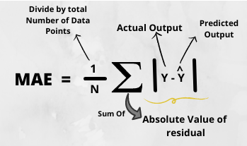

Source: (Agrawal, 2021)

**Figure** 7.1 MAE

**MSE:** It states, finding the squared difference between actual and predicted value. It identifies the squared distance between actual and predicted values. It is performed to avoid the cancellation of negative terms and it is the benefit of MSE.

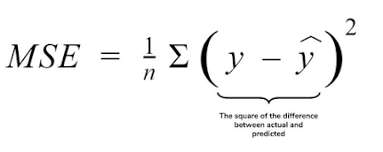

Source: (Agrawal, 2021)

**Figure** 7.2 MSE

**RMSE:** It is just the square root of mean squared error. It is highly preferred for deep learning techniques for performance evaluation.

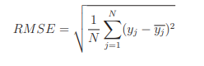

Source: (Agrawal, 2021)

**Figure** 7.3 RMSE

**R2:** It is the one that tells about how well the model has performed. It does not depend on context for calculations like MSE and MAE. Basically, it calculates how must regression line is better than a mean line.

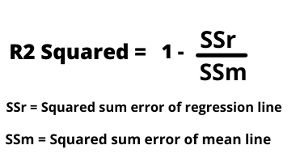

Source: (Agrawal, 2021)

**Figure** 7.4 R2

# **7.1.2 Machine Learning Models**

After doing all the preprocessing steps mentioned in the preprocessing section, I come up with ready to use data. It contains , eight air pollutants concentration PM2.5 (ug/m3), PM10 (ug/m3), NO (ug/m3), NO2 (ug/m3), NOx (ppb), NH3 (ug/m3), SO2 (ug/m3), CO (mg/m3) as an input to predict AQI. Also, it includes One Hot encoded columns of three states and 22 cities in it having one monitoring station in each city. As it is a time series data, so the index is set as a time stamp.

# **CatBoost Regressor**

The algorithm has been trained with by default setting. Training and testing dataset were provided for the prediction of AQI. The interpretation of results is shown below.

'depth': 6, 'iterations': 500, 'learning_rate': 0.1, 'loss_function': 'RMSE', 'random_seed': 42 found to be the best parameters after GridSearchCV.

|  |  |  |  |  |
| --- | --- | --- | --- | --- |
| Performance Metric | MSE | RMSE | MAE | R2 |
| Before Hypertuning | 0.0011 | 0.0335 | 0.0127 | 0.9985 |
| After Hypertuning | 0.0012 | 0.0355 | 0.0160 | 0.9983 |

**Table 7.1** Performance Metrics CatBoost

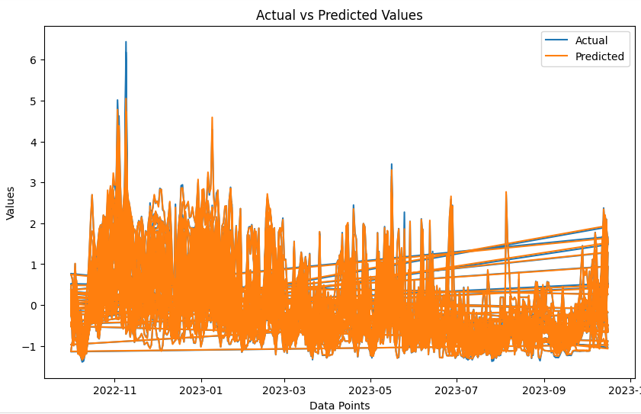

**Figure 7.5** CatBoost Regressor Model

**Note:** Horizontally passing lines at back of the graph should be ignored. This is because I am predicting for multiple monitoring stations at the same time, means there are 22 records to be predicted for the same day.

For more clear visualizations of predictions, I have created graphs in Tableau. The predictions of peak period of both the higher AQI and stubble burning activities are shown in the following figures. The figure shown are just for the Delhi states which is the most polluted states of India. But you are free to explore for rest of the states and cities at tableau dashboard. I will attach links to access this visualization on tableau.

# **1.1 Visualization of model predictions VS Actual values:**

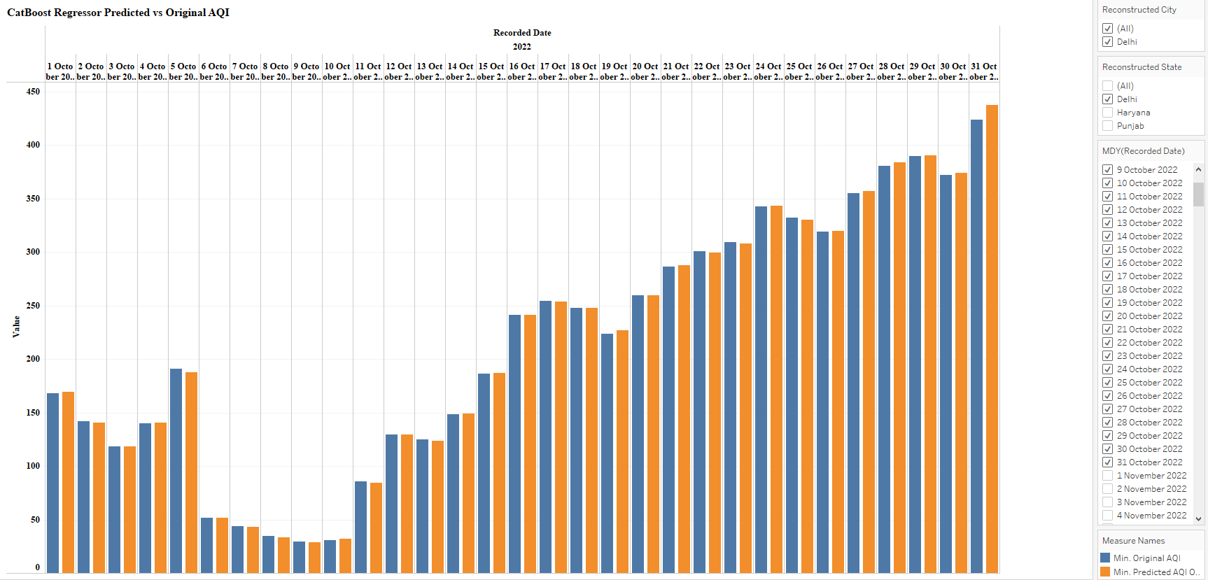

**Figure 7.6** CatBoost R Predictions of October 2022

The model is predicting AQI accurately except minor differences where the concentration of AQI is extremely high as compared to rest of the days. A difference can be notice in the prediction for 31st October 2022. This visualization highlights significant change in AQI each passing day, because it is the beginning of peak period. From October onwards AQI will be at its peak till end of January next year.

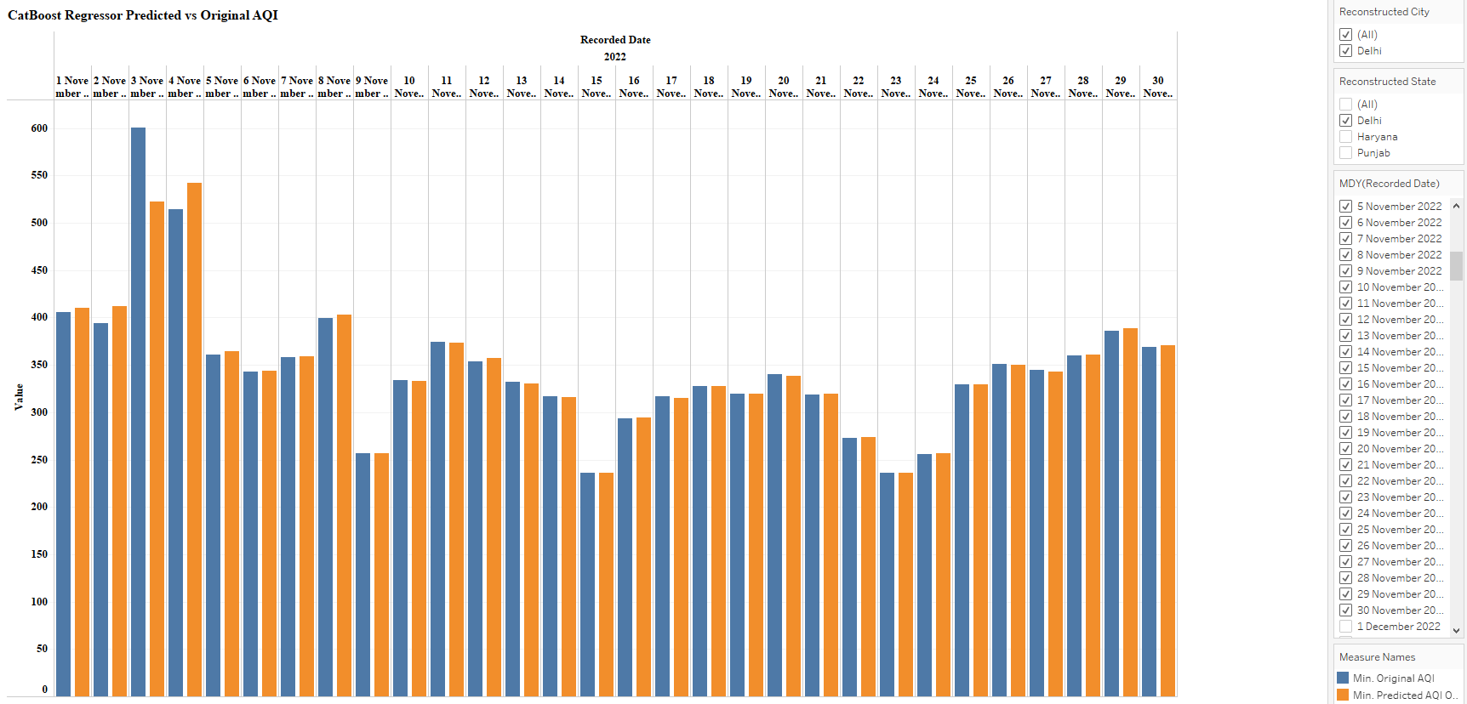

**Figure 7.7** CatBoost R Predictions of November 2022

November is the peak period for higher AQI concentrations. But the model is not highly capable top predict such excessive peaks in the data. Like on 3rd and 4th November a huge difference can be noticed in the actual and predicted values.

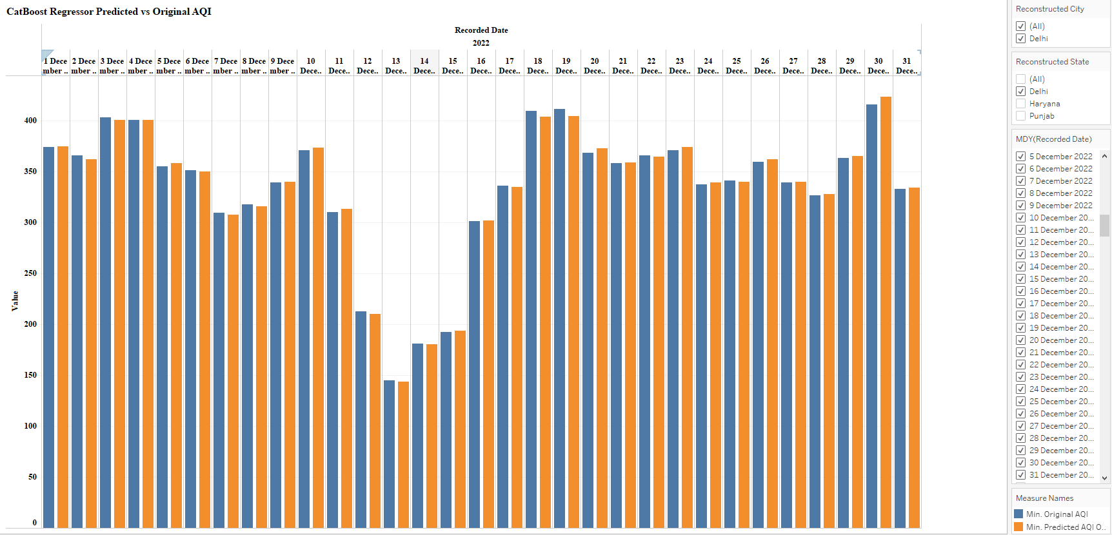

**Figure 7.8** CatBoost R Predictions of December 2022

It is clear from the visualization; the model can predict the lows in the data like it shows between 12th to 15th December 2022.

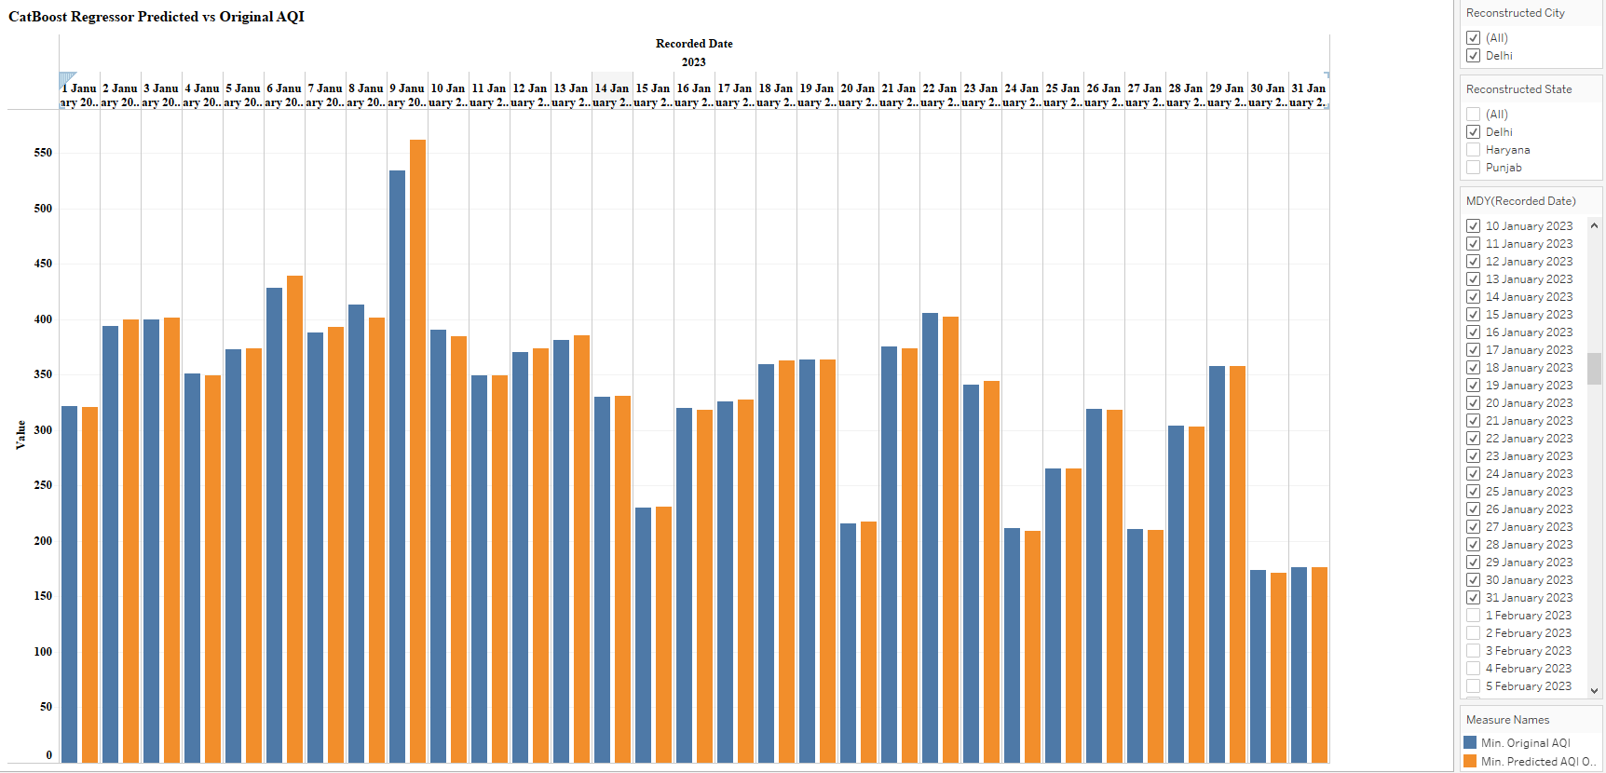

**Figure 7.9** CatBoost R Predictions of January 2023

January is the last month of this peak period; it can be seen in figure that the concentration of AQI is decreasing steadily by the end on month. And it will almost be at lower index until the next peak period.

# **Performance matrix evaluation:**

It can be analysed from the matric that MSE and RMSE are quite low, which indicates a better fit of the model. The model is capable to predict the data accurately except some major spikes in November 2022 when the AQI concentration was too high. Moreover, R2 of 99.85% has been achieved, which is quite impressive considering all preprocessing steps applied in this research. Even, MAE is found to be low. However, after hypertuning there is almost negligible difference in model’s performance.

# **1.3 Important Features for CatBoost R:**

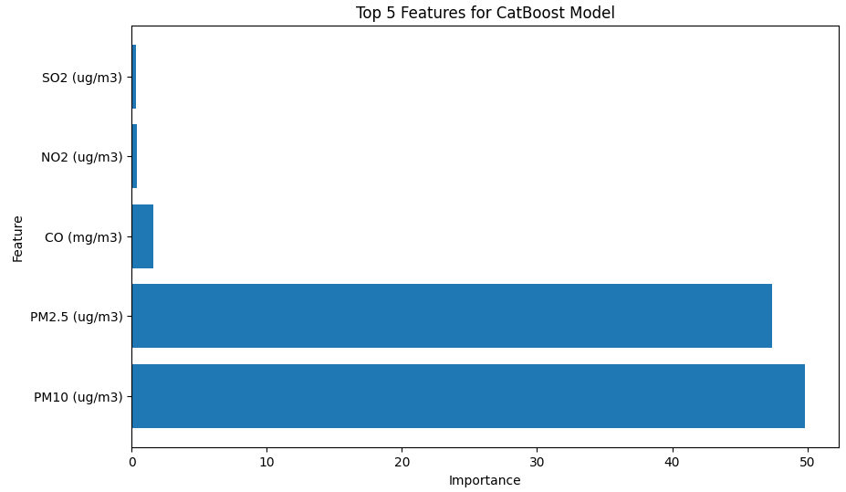

**Figure 7.10** Feature Importance for CatBoost Regressor Model

Feature importance bar graph shows, CatBoost has highly considered the concentration of PM 10 and PM 2.5 for predicting AQI. Even in real it is proven that both pollutants are more dangerous as compared to other pollutants and it impacts seriously especially for human health. Centre of Disease Control and Prevention (CDCP) (“Particle Pollution | Air | CDC,” 2023) states, Coarse (bigger) particles, called PM10, can irritate eyes, nose, and throat. The types of PM 10 that we inhale is dust from roads, farms, dry riverbeds, construction sites, and mines. Whereas, fine (smaller) particles, called PM2.5, are more dangerous because they can get into the deep parts of lungs or even into blood.

# **1.4 Residuals Distribution:**

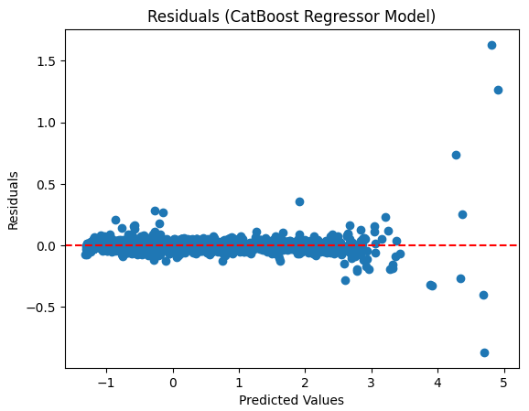 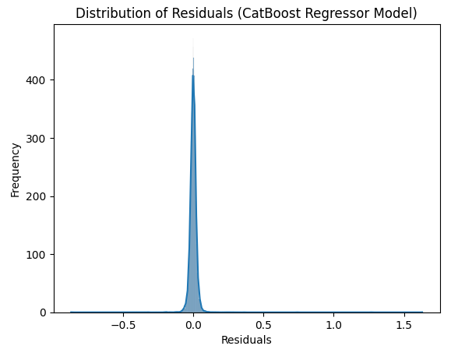

**Figure 7.11** Residuals Distribution in CatBoost Regressor Model

In regression model residuals are defined as the difference between the actual and predicted values. As shown in figure 7.7, the distribution of residuals cantered around 0.0 in a regression analysis suggests, model is making predictions that are very close to the actual value. In detail a positive residual indicates, the model underpredicts the actual value. Whereas, a negative residual indicates, the model overpredicts the actual value.

In this research, the residuals are centred around 0.0, it implies, the model is unbiased, and the errors are distributed symmetrically on both sides of 0.0. It is a desirable characteristic of a regression model, as it suggests, the model is not consistently overpredicting or underpredicting.

# **XGBoost model**

At first the model is trained with default parameters only, having almost None for every parameter. Then, GridSearchCV has been used to get best hyperparameters for XGB Regressor.

'learning_rate': 0.1, 'max_depth': 6, 'n_estimators': 300 with 'random_seed': 42 found to be the best parameters after GridSearchCV. The performance has been evaluated for both the scenarios before and after applying hypertuning.

|  |  |  |  |  |
| --- | --- | --- | --- | --- |
| Performance Metric | MSE | RMSE | MAE | R2 |
| Before Hypertuning | 0.0012 | 0.0354 | 0.0102 | 0.9983 |
| After Hypertuning | 0.0011 | 0.0337 | 0.0084 | 0.9985 |

**Table 7.12** Performance Metrics XGBoost Regressor

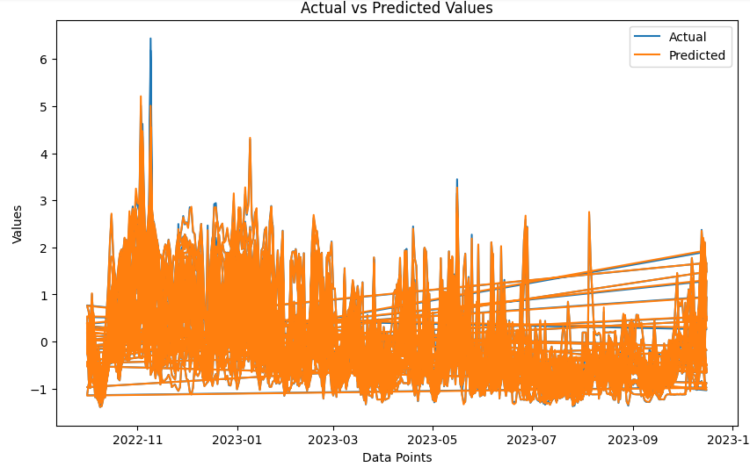

**Figure 7.12** XGBoost Regressor Model

# **2.1 Visualization of model predictions VS Actual values:**

**For more clear visualizations of predictions, I have created graphs in Tableau. The predictions of peak period of both the higher AQI and stubble burning activities are shown in the following figures. The figure shown are just for the Delhi states which is the most polluted states of India. But you are free to explore for rest of the states and cities at tableau dashboard. I will attach links to access this visualization on tableau.**

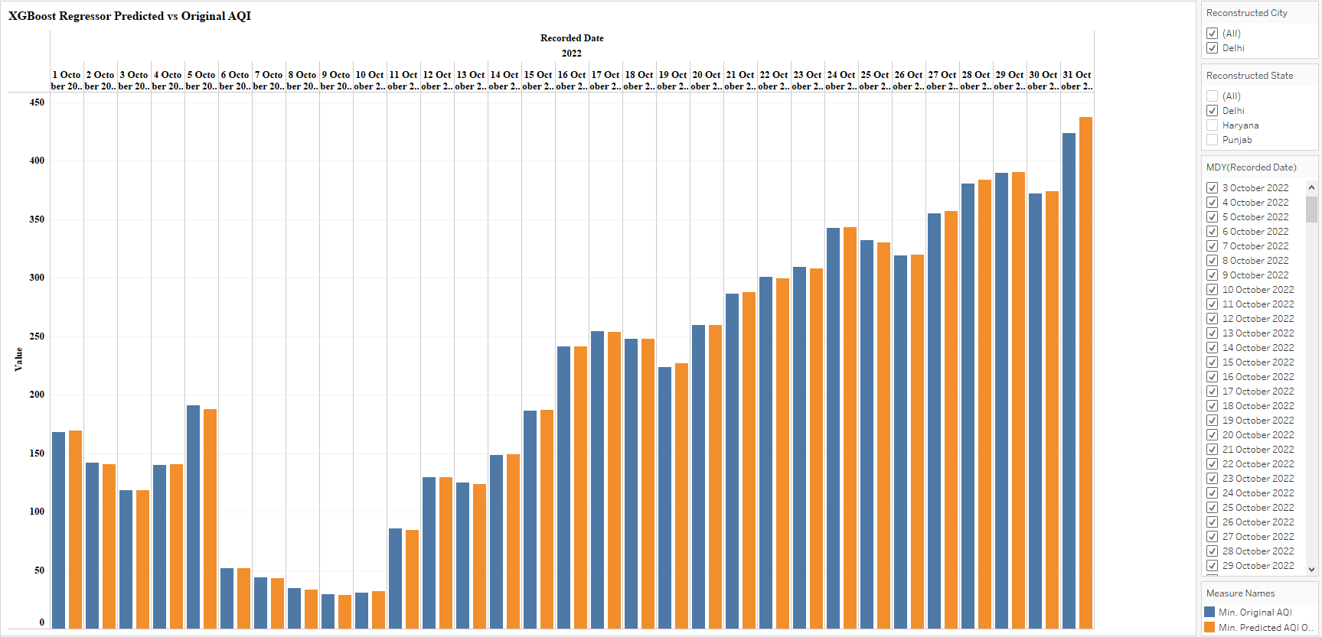

**Figure 7.13** XGB R Predictions of October 2022

The model is predicting AQI accurately except minor differences where the concentration of AQI is extremely high as compared to rest of the days. A difference can be notice in the prediction for 5th October and 31st October 2022.

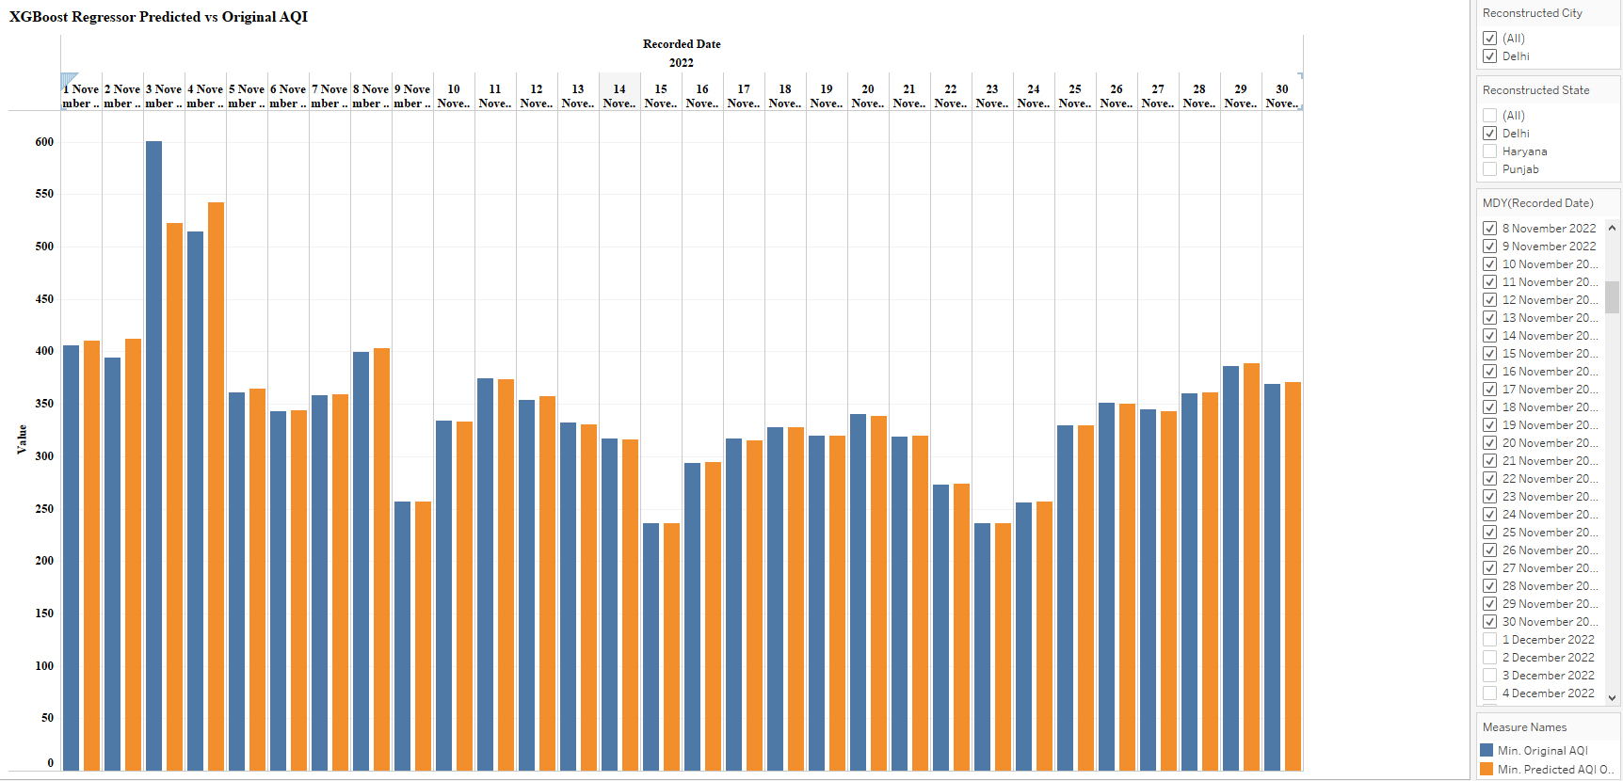

**Figure 7.14** XGB R Predictions of November 2022

Similarly in the peak month, November 2022, a noticeable variation can be seen in the predictions for 3rd and 4th November. This is the peak period of stubble burning, also a popular Indian festival known as Diwali falls in this month only, on this festival excessive fire work activities take place.

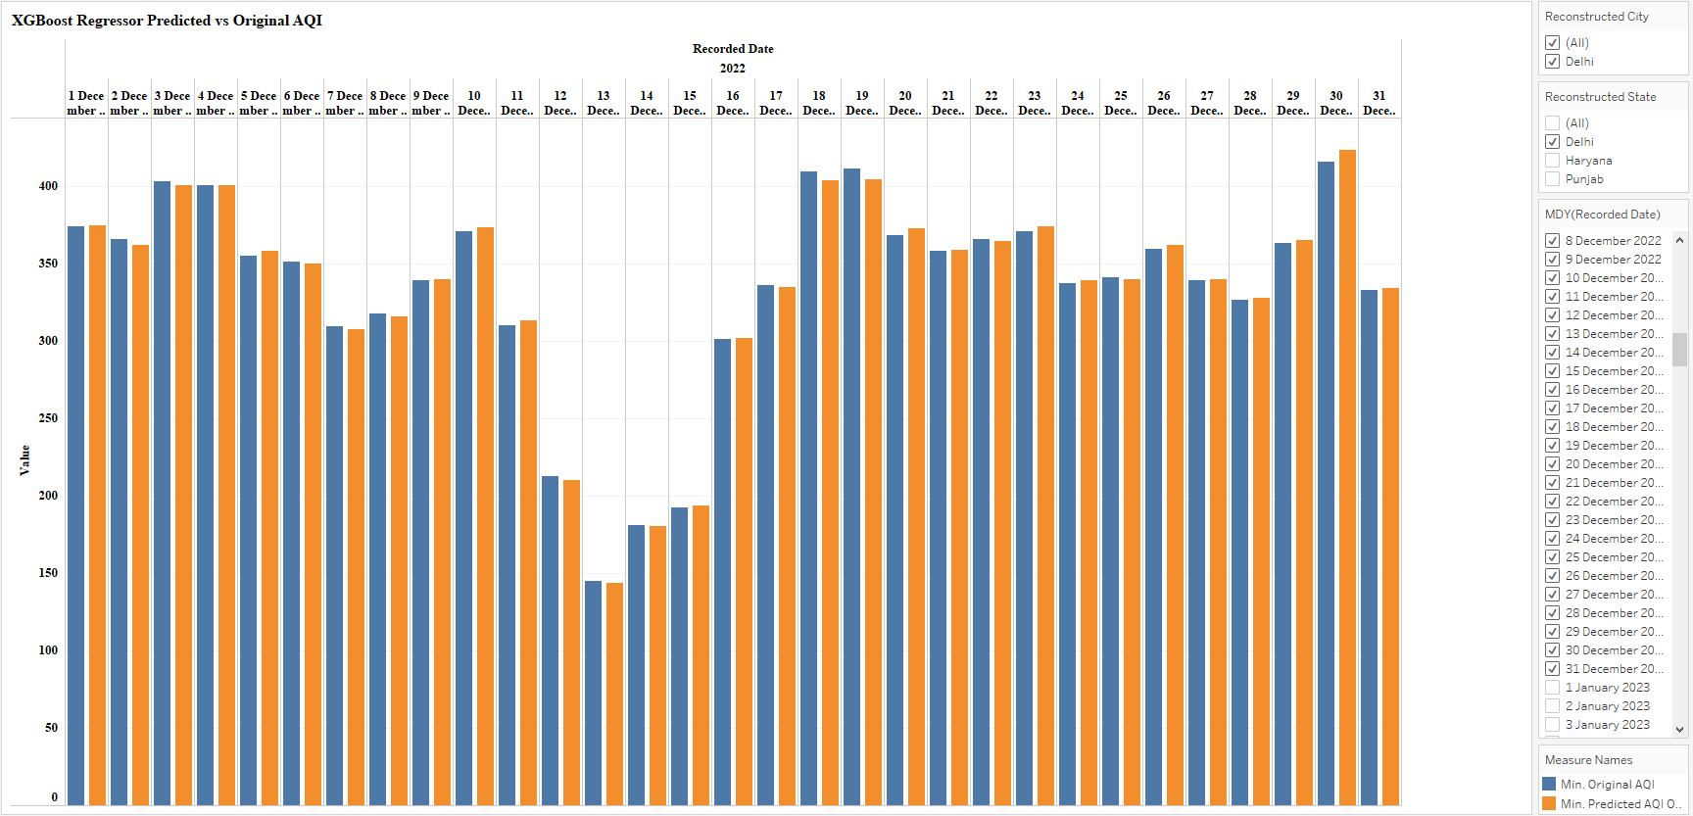

**Figure 7.15** XGB R Predictions of December 2022

It is crystal clear; the model can track all the ups and downs in the data like it did for 12th to 15th December 2022.

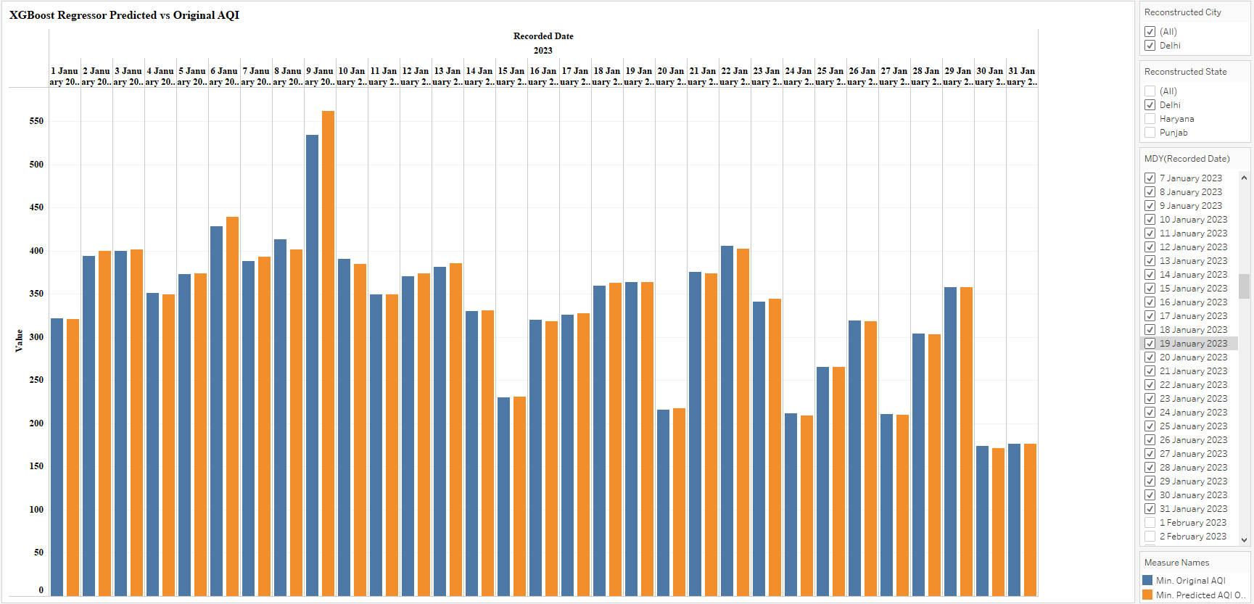

**Figure 7.16** XGB R Predictions of January 2022

From January onwards the AQI started decreasing steadily and it will remain at lows until the next peak period. For further analysis you can explore the dashboard of Tableau.

# **Performance matrix evaluation:**

The performance metrics of XGBoost is almost same as of CatBoost. It is visible from the time series graph that the model is not comfortable to predict the excessive hikes accurately like November 2022.

It can be analysed from the performance matric; it is a better fit of the model. Moreover, R2 of 99.85% has been achieved as of CatBoost Regressor. Even, MAE is found to be low. Moor differences are noticed after hypertuning.

# **2.2 Residuals Distribution:**

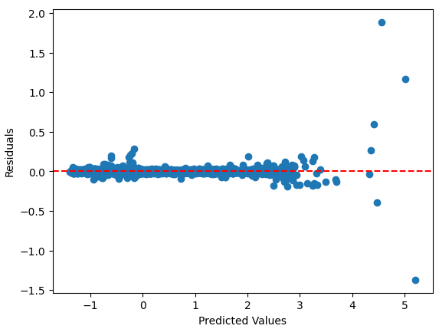 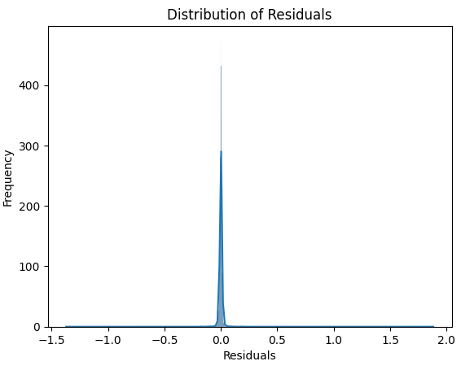

**Figure 7.17** Residuals Distribution in XGB Regressor Model

As shown in figure 7.18, the distribution of residuals is more tightly cantered around 0.0 as compared to CatBoost model. Even, the XGBoost model is not consistently overpredicting or underpredicting.

# **Random Forest model**

The perform of RF Regressor has been examined before and after hypertuning. The following values are used for hyper tuning max_depth=8, max_features='auto', n_estimators=200, random_state=42 using Grid Search.

|  |  |  |  |  |
| --- | --- | --- | --- | --- |
| Performance Metric | MSE | RMSE | MAE | R2 |
| Before Hypertuning | 0.0001 | 0.0107 | 0.0018 | 0.9998 |
| After Hypertuning | 0.0010 | 0.0325 | 0.0150 | 0.9986 |

**Table 7.13** Performance Metrics Random Forest Regressor

# **Performance Matrix Evaluation**

The matrix MSE, RMSE and MAE are very low, which indicates the accurate prediction of AQI by RF R model. Also, R2 is very close to 1, it means the model explains almost all the variability in the target variable.

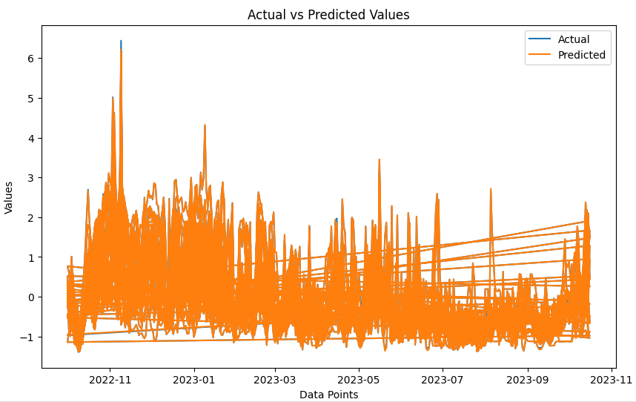

**Figure 7.18** RF Regressor Model Predictions

RF Regressor Model is predicting the highest values more accurately compared to previous two models. There is just minor blue line showing in November 2022.

# **3.2 Visualization of model predictions VS Actual values:**

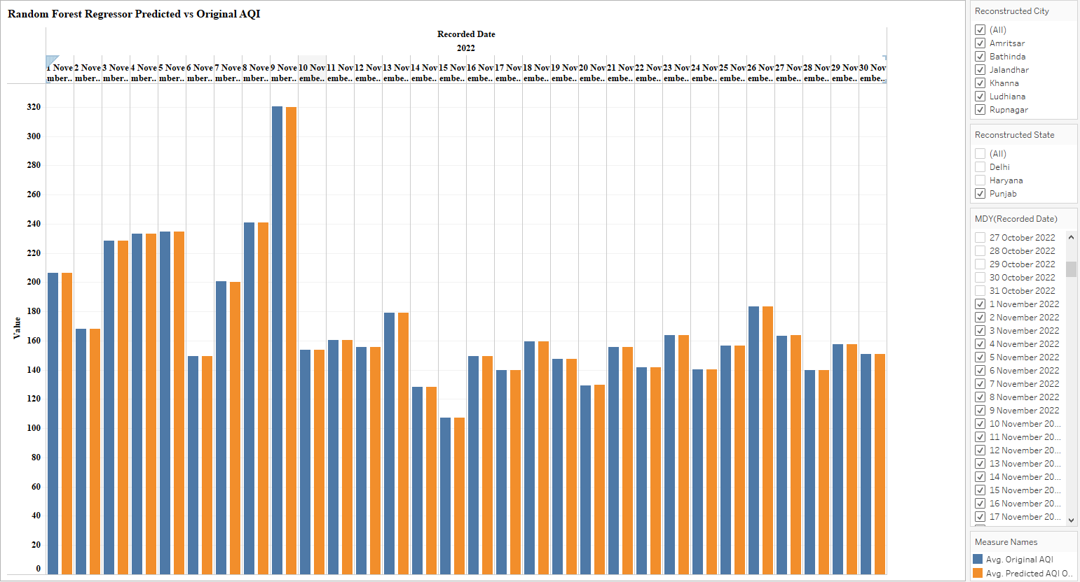

**Figure 7.19** RF Regressor Model November 2022 (Punjab)

Random Forest regressor is predicting accurately even the peaks of November 2022. **As November is the peak period for AQI concentration and most of the stubble burning activities during this month take place in Punjab are believed to be responsible for the higher number of AQI in Delhi (Govardhan et al., 2023). But I analysed from the visualizations that even during peak time the highest AQI was around 300 units, whereas, in Delhi it was two times of it, means the AQI was 600 units in November 2022.**

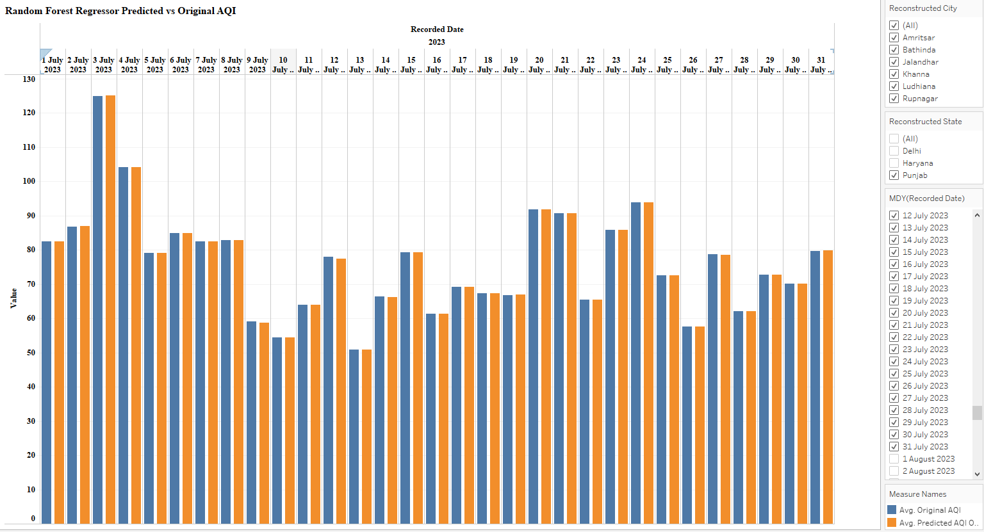

**Figure 7.20** RF Regressor Model July 2022 (Punjab)

In July the AQI remain at its lowest level almost in every state as compared to other time of the year. The lowest value of AQI in Punjab is 50 during the quite period.

# **Residuals Distribution:**

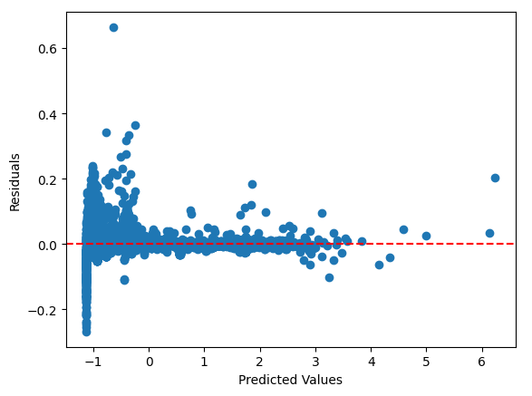 

**Figure 7.21** Residuals Distribution in RF Regressor Model

The distribution of residuals is tightly cantered around 0.0.

# **Support Vactor Regressor**

At first model was trained with default parameter values. Then using GridSearchCV I found best parameters to use for SVR for this data. The performance matrix of before and after imputing hyperparameter tuning has shown below.

The value for C = 10 and kernal= rbf found to be the best parameters for SVR

|  |  |  |  |  |
| --- | --- | --- | --- | --- |
| Performance Metric | MSE | RMSE | MAE | R2 |
| Before Hypertuning | 0.0148 | 0.1220 | 0.0761 | 0.9808 |
| After Hypertuning | 0.0141 | 0.1191 | 0.0731 | 0.9817 |

**Table 7.14** Performance Metrics SVM Regressor

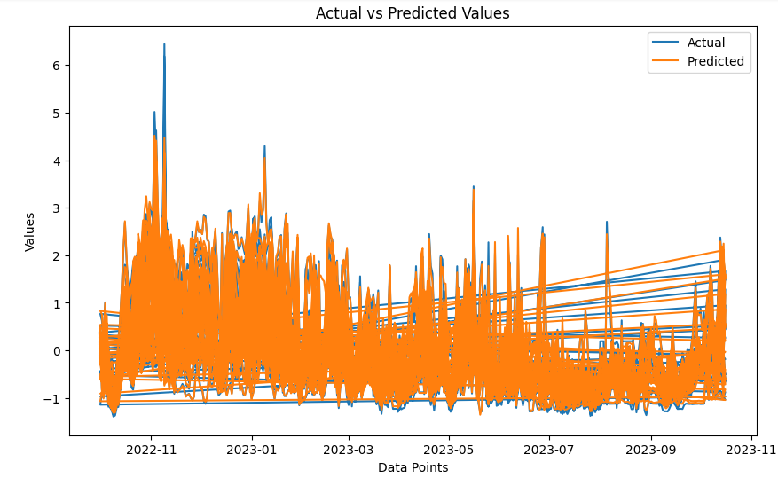

**Figure 7.22** Support Vactor Regressor Model

The difference between actual and predicted values is quite clear from the graph. The model is missing some patterns to capture and remember while predicting.

# **4.1 The residuals Distributions**

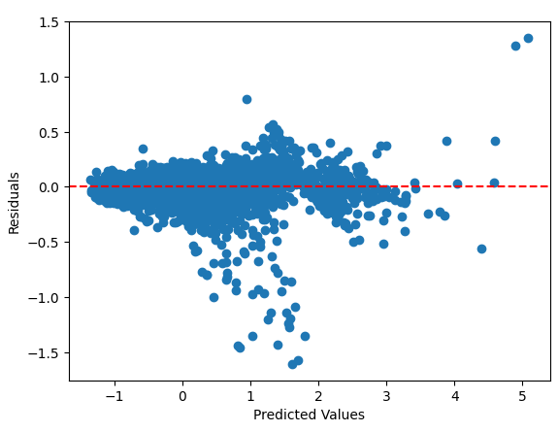 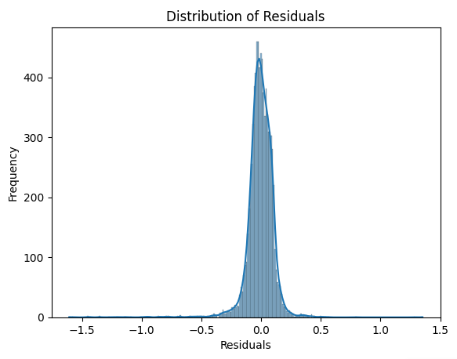

**Figure 7.23** Residuals Distribution in SVR Model

The fact, the residuals fall within the range of -1.5 to 1.5 indicates, on average, the model's predictions deviate by no more than 1.5 units from the actual values.

# **7.1.3 Time Series Model**

# **SARIMAX**

As I am working on time series data and there is clear seasonality in data, so SARIMAX model is used to predict the AQI. The understanding of values used for SARIMAX is described below. For this model, daily basis dataset of Delhi states is used. At one time it can be used to predict for one location and one variable only. I have data of 22 different locations but due to the limitation of computational resources I have used SARIMAX to predict AQI for Delhi. The data is spitted into same split as for other models. But the models can be used for other locations as well. The performance of SARIMAX predicting model is explained below.

# **Theoretical Understanding of parameters**

**m:** As per the interpretation of ACF the seasonal period is set to 4. This is also backed by my subject matter knowledge.

**p:** As per a significant peak shown at lag 1 in ACF, autoregressive order is set to1.

**d:** The Dickey-Fuller test revealed that the data is stationary, so no differencing is needed for data.

**q:** The gradual decline in ACF until lag 4 suggests that a moving average order of 4 might be appropriate.

**P:** Since there is a significant peak at lag 1 so the seasonal autoregressive order can be set to 1.

**D:** The data is stationary, so no differencing is needed for data and D will be set to 0.

**Q:** The ACF remains relatively constant until lag 12, so the seasonal moving average order can be set to a small value like 1.

The performance matrix of SARIMAX after hypertuning the above-mentioned parameters is mentioned below.

|  |  |  |  |  |
| --- | --- | --- | --- | --- |
| Performance Metric | MSE | RMSE | MAE | R2 |
| After Hypertuning | 0.1329 | 0.3646 | 0.3067 | 0.9105 |

**Table 7.15** Performance Metrics of SARIMAX

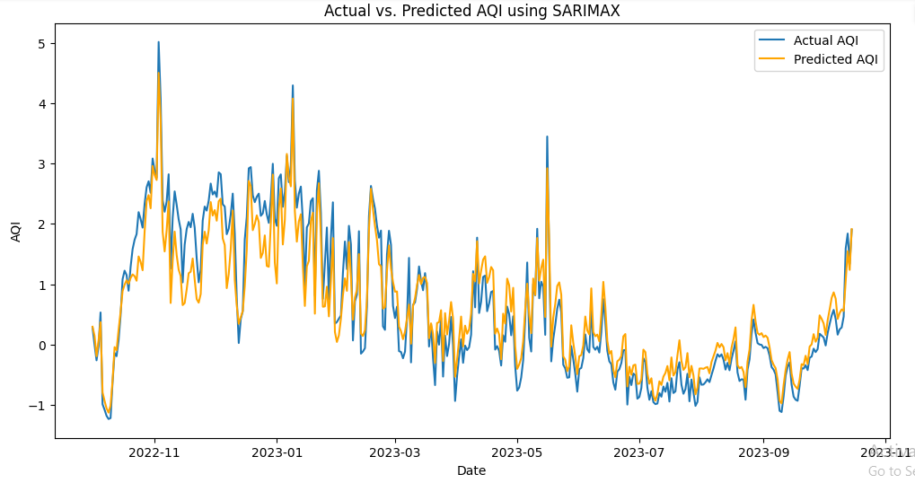

**Table 7.24** SARIMAX Predictions (Delhi)

# **Performance Matrix Evaluation**

As the SARIMAX is just used for one States so prediction graph appears clearer. The values of MSE, RMSE and MAE are low, which suggests that, on average, model's predictions deviate by approximately 0.1329, 0.3646 and 0.3067 units from the actual values. The R2 value of 0.9105 is relatively high and close to 1,which indicates that the SARIMAX model explains about 91.05% of the variance in the target variable. This suggests that the model is a good fit to the used data.

# **Residuals Distribution**

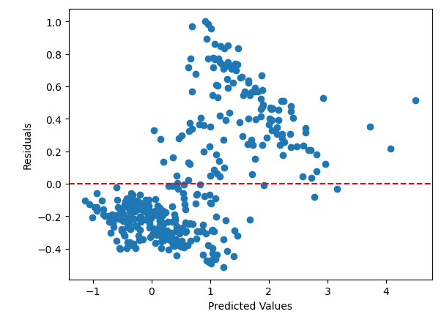 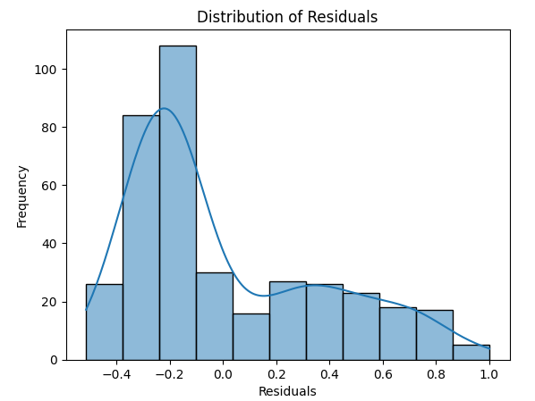

**Figure 7.25** Residuals Distribution of SARIMAX Model

Positive residuals above 0 indicates, the model is underfitting the actual values, while negative residuals below 0 indicates overfitting. However, the larger residuals range like 1.0 to -0.4 represent a significant deviation between the predicted and actual values.

# **7.1.4 Deep Learning Model**

# **LSTM**

From deep learning models LSTM has been used on the same set of data to predict AQI. But instead of Standard Scaler I have used Min Max Scaler as it is more appropriate for time series data. I have shared the performance matrix of LSTM model below.

To use LSTM for this data I have given ‘adam’ as an optimizer and mean square error has been used for calculating loss function. Fifty epoch is given to epoch and batch size of 32.

|  |  |  |  |  |
| --- | --- | --- | --- | --- |
| Performance Metric | MSE | RMSE | MAE | R2 |
| After Hypertuning | 0.0067 | 0.0823 | 0.0632 | 0.6057 |

**Table 7.16** Performance Metrics of LSTM

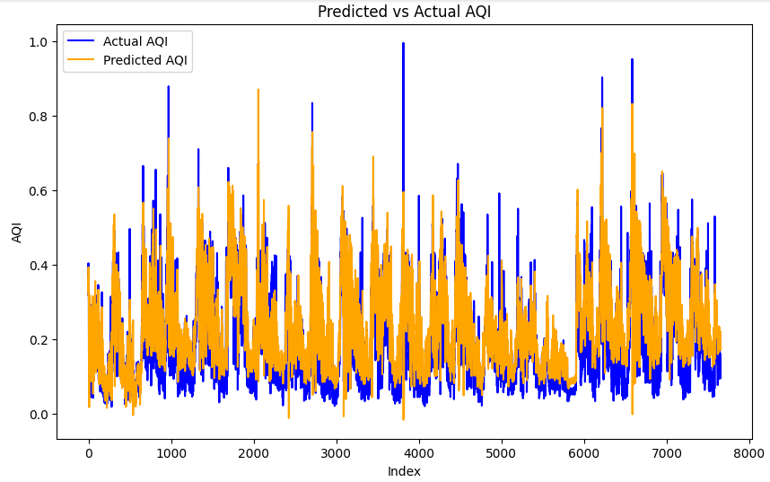

**Figure 7.26** LSTM Predictions

# **Performance Matrix Evaluation of LSTM**

The value of MSE suggests a relatively low level of prediction error. RMSE and MAE reveal that on an average, model’s prediction deviates by approximately 0.0823 and 0.0632 units from the actual values. However, R2 value reveals that 60.67% of variance in the actual variable.

# **7.2 Experimentation and Results Evaluation**

The evaluation of various models based on different performance measure metrics presents a comprehensive view of their predictive capabilities for AQI.

|  |  |  |  |  |
| --- | --- | --- | --- | --- |
| Performance Metric | MSE | RMSE | MAE | R2 |
| Random Forest | 0.0001 | 0.0107 | 0.0018 | 0.9998 |
| CatBoost | 0.0011 | 0.0335 | 0.0127 | 0.9985 |
| XGBoost | 0.0011 | 0.0337 | 0.0084 | 0.9985 |
| SVR | 0.0141 | 0.1191 | 0.0731 | 0.9817 |
| SARIMAX | 0.1329 | 0.3646 | 0.3067 | 0.9105 |
| LSTM | 0.0067 | 0.0823 | 0.0632 | 0.6057 |

**Table 7.17** Performance Metrics of all the models

**Figure 7.27** Performance Matrix of all the used Models

The main matrix for model’s performance evaluation especially for regression models is R2. Mainly I am just considering four ML models into comparison, because SARIMAX has not been used for the whole dataset as other models are used. So, comparing it with other models is not a good approach. But it can be considered when predicting for same set of locations using all the models. It is clear from the above mentioned figure that the value of R2 is almost 1 for Random Forest regressor followed by CatBoost and XGBoost ML models. It means these models has explained all the variability in the dependent variable. Also the other matrices are quite low which indicates, there are less errors made while predicting the actual values. Overall, RFR seems to be the best model among others used in this research. Also, the residuals are tightly scattered around 0.0, which means on an average model is predicting correct. In other words model is not systematically overpredicting or underpredicting. However, for the time series and deep learning models, highly computational resources are needed especially for LSTM. Because running higher number of Epoch takes a lot of time and computational power, which is not an easy task. Having access to these resources will allow to check on further improvements of these models.

# **8. Limitations**

The major limitation for this research is the lack of desired datasets. There is almost no data about meteorological factors like Temperature, humidity, wind direction etcetera. Having access to this data will help to find more interesting insights out of data. Moreover, to run complex models like LSTM especially on big dataset needs huge computational power, which is not easily available. It limited this research to decide on common parameters for LSTM rather than using GridSearchCV for passing multiple values to check for best match as per data.

# **9. Future Scope**

ML regression models like Random Forest, CatBoost, XGBoost has performed well on this dataset, further these models can be used on similar datasets. And it is recommended to use the meteorological data as well if available, it might come up with new findings. Further SARIMAX can be used to predict AQI for remaining states like Haryana and Punjab or specific cities. LSTM model can be applied for similar data with by following required preprocessing steps.

# **10. Conclusion**

Various authors have implemented ML models to solve the same problem that has been handled in this paper. Researchers have implemented models like CatBoost Regressor, SVM, SARIMAX, Random Forest etcetera for various AQI components. In this paper almost all the preprocessing steps are followed with approach as per the needs of data. The biggest issue that affects any ML model is the availability of null values, which is handled very well in this research using imputation. To evaluate the performance of used models MSE, RMSE, MAE and R2 metrics are used. The comparison shows that Random Forest performed the best and then closely followed by CatBoost and XGBoost regressor models. Apart from technical part, it is found that the stubble burning in Punjab or Haryana might impacts the air quality of Delhi, but it is not the only reason for bad air quality.

# **References:**

A comparative analysis of LSTM and ARIMA for enhanced real-time air pollutant levels forecasting using sensor fusion with ground station data [WWW Document], n.d. URL https://www.tandfonline.com/doi/epdf/10.1080/23311916.2021.1936886?src=getftr (accessed 12.26.23).

Abdurrahman, M.I., Chaki, S., Saini, G., 2020. Stubble burning: Effects on health & environment, regulations and management practices. Environmental Advances 2, 100011. https://doi.org/10.1016/j.envadv.2020.100011

Agrawal, R., 2021. Know The Best Evaluation Metrics for Your Regression Model ! Analytics Vidhya. URL https://www.analyticsvidhya.com/blog/2021/05/know-the-best-evaluation-metrics-for-your-regression-model/ (accessed 1.10.24).

Air pollution [WWW Document], 2023. URL https://www.who.int/india/health-topics/air-pollution (accessed 12.21.23).

Ambient (outdoor) air pollution [WWW Document], 2022. URL https://www.who.int/news-room/fact-sheets/detail/ambient-(outdoor)-air-quality-and-health (accessed 12.21.23).

Arora, A., Kumari, A., Kulshrestha, U., 2018. Respirable Mercury Particulates and Other Chemical Constituents in Festival Aerosols in Delhi. Current World Environment 13, 3–14. https://doi.org/10.12944/CWE.13.1.02

Arora, H., Solanki, A., 2020. Prediction of Air Quality Index in Metro Cities using Time Series Forecasting Models. Xi’an Jianzhu Keji Daxue Xuebao/Journal of Xi’an University of Architecture & Technology 12, 3052–3067. https://doi.org/10.37896/JXAT12.05/1721

Ayturan, Y.A., Ayturan, Z.C., Altun, H.O., 2018. Air Pollution Modelling with Deep Learning: A Review. Environmental Modelling 1.

Balakrishnan, K., Dey, S., Gupta, T., Dhaliwal, R.S., Brauer, M., Cohen, A.J., Stanaway, J.D., Beig, G., Joshi, T.K., Aggarwal, A.N., Sabde, Y., Sadhu, H., Frostad, J., Causey, K., Godwin, W., Shukla, D.K., Kumar, G.A., Varghese, C.M., Muraleedharan, P., Agrawal, A., Anjana, R.M., Bhansali, A., Bhardwaj, D., Burkart, K., Cercy, K., Chakma, J.K., Chowdhury, S., Christopher, D.J., Dutta, E., Furtado, M., Ghosh, S., Ghoshal, A.G., Glenn, S.D., Guleria, R., Gupta, R., Jeemon, P., Kant, R., Kant, S., Kaur, T., Koul, P.A., Krish, V., Krishna, B., Larson, S.L., Madhipatla, K., Mahesh, P.A., Mohan, V., Mukhopadhyay, S., Mutreja, P., Naik, N., Nair, S., Nguyen, G., Odell, C.M., Pandian, J.D., Prabhakaran, D., Prabhakaran, P., Roy, A., Salvi, S., Sambandam, S., Saraf, D., Sharma, M., Shrivastava, A., Singh, V., Tandon, N., Thomas, N.J., Torre, A., Xavier, D., Yadav, G., Singh, S., Shekhar, C., Vos, T., Dandona, R., Reddy, K.S., Lim, S.S., Murray, C.J.L., Venkatesh, S., Dandona, L., 2019. The impact of air pollution on deaths, disease burden, and life expectancy across the states of India: the Global Burden of Disease Study 2017. The Lancet Planetary Health 3, e26–e39. https://doi.org/10.1016/S2542-5196(18)30261-4

Bennett, D.A., 2001. How can I deal with missing data in my study? Australian and New Zealand Journal of Public Health 25, 464–469. https://doi.org/10.1111/j.1467-842X.2001.tb00294.x

Breiman, L., 2001. Random Forests. Machine Learning 45, 5–32. https://doi.org/10.1023/A:1010933404324

bsquare, 2020. Answer to “Importance of number of steps in an epoch for LSTM model training in Keras.” Stack Overflow.

Calculating AQI (Air Quality Index) Tutorial [WWW Document], n.d. URL https://kaggle.com/code/rohanrao/calculating-aqi-air-quality-index-tutorial (accessed 12.28.23).

Carnevale, C., Ferrari, F., Guariso, G., Maffeis, G., Turrini, E., Volta, M., 2018. Assessing the Economic and Environmental Sustainability of a Regional Air Quality Plan. Sustainability 10, 3568. https://doi.org/10.3390/su10103568

CCR [WWW Document], n.d. URL https://airquality.cpcb.gov.in/ccr/#/caaqm-dashboard-all/caaqm-landing/data (accessed 12.31.23).

Chowdhury, S., Dey, S., Guttikunda, S., Pillarisetti, A., Smith, K.R., Di Girolamo, L., 2019. Indian annual ambient air quality standard is achievable by completely mitigating emissions from household sources. Proceedings of the National Academy of Sciences 116, 10711–10716. https://doi.org/10.1073/pnas.1900888116

Cusworth, D.H., Mickley, L.J., Sulprizio, M.P., Liu, T., Marlier, M.E., DeFries, R.S., Guttikunda, S.K., Gupta, P., 2018. Quantifying the influence of agricultural fires in northwest India on urban air pollution in Delhi, India. Environ. Res. Lett. 13, 044018. https://doi.org/10.1088/1748-9326/aab303

Das, P., Behera, M., Abhilash, P., 2023. A rapid assessment of stubble burning and air pollutants from satellite observations. Trop Ecol 1–6. https://doi.org/10.1007/s42965-022-00291-5

displaypdf.pdf, n.d.

Dun, M., Xu, Z., Chen, Y., Wu, L., 2020. Short-Term Air Quality Prediction Based on Fractional Grey Linear Regression and Support Vector Machine. Mathematical Problems in Engineering 2020, e8914501. https://doi.org/10.1155/2020/8914501

Emmanuel, T., Maupong, T., Mpoeleng, D., Semong, T., Mphago, B., Tabona, O., 2021. A survey on missing data in machine learning. J Big Data 8, 140. https://doi.org/10.1186/s40537-021-00516-9

Ergun, B., Kavzoglu, T., Colkesen, I., Şahin, C., 2010. Data filtering with support vector machines in geometric camera calibration. Optics express 18, 1927–1936. https://doi.org/10.1364/OE.18.001927

Fernando, I., 2021. Outliers - To Remove, Or Not To Remove? [WWW Document]. Quantics Biostatistics. URL https://www.quantics.co.uk/blog/outliers/ (accessed 1.3.24).

Filho, M., 2023. CatBoost Hyperparameter Tuning Guide with Optuna [WWW Document]. URL https://forecastegy.com/posts/catboost-hyperparameter-tuning-guide-with-optuna/ (accessed 1.4.24).

FINAL-REPORT_AQI_.pdf, n.d.

Ghei, D., Sane, R., 2018. Estimates of air pollution in Delhi from the burning of firecrackers during the festival of Diwali. PLOS ONE 13, e0200371. https://doi.org/10.1371/journal.pone.0200371

Gopalakrishnan, V., 2023. Hyperlocal Air Quality Prediction using Machine Learning [WWW Document]. Medium. URL https://towardsdatascience.com/hyperlocal-air-quality-prediction-using-machine-learning-ed3a661b9a71 (accessed 12.28.23).

Govardhan, G., Ambulkar, R., Kulkarni, S., Vishnoi, A., Yadav, P., Choudhury, B.A., Khare, M., Ghude, S.D., 2023. Stubble-burning activities in north-western India in 2021: Contribution to air pollution in Delhi. Heliyon 9, e16939. https://doi.org/10.1016/j.heliyon.2023.e16939

Guo, J., Feng, Z., 2019. Study on Spatial Temporal Distribution Characteristics of Air Quality Index in Beijing and Its Correlation with Local Meteorological Conditions. Discrete Dynamics in Nature and Society 2019, e1462034. https://doi.org/10.1155/2019/1462034

Gupta, N.S., Mohta, Y., Heda, K., Armaan, R., Valarmathi, B., Arulkumaran, G., 2023. Prediction of Air Quality Index Using Machine Learning Techniques: A Comparative Analysis. Journal of Environmental and Public Health 2023, e4916267. https://doi.org/10.1155/2023/4916267

Haixiang, G., Yijing, L., Shang, J., Mingyun, G., Yuanyue, H., Bing, G., 2017. Learning from class-imbalanced data: Review of methods and applications. Expert Systems with Applications 73, 220–239. https://doi.org/10.1016/j.eswa.2016.12.035

Kumar, K., Pande, B.P., 2023. Air pollution prediction with machine learning: a case study of Indian cities. Int J Environ Sci Technol (Tehran) 20, 5333–5348. https://doi.org/10.1007/s13762-022-04241-5

Li, X., Peng, L., Yao, X., Cui, S., Hu, Y., You, C., Chi, T., 2017. Long short-term memory neural network for air pollutant concentration predictions: Method development and evaluation. Environmental Pollution 231, 997–1004. https://doi.org/10.1016/j.envpol.2017.08.114

Liu, B., Guo, X., Lai, M., Wang, Q., 2020. Air Pollutant Concentration Forecasting Using Long Short-Term Memory Based on Wavelet Transform and Information Gain: A Case Study of Beijing. Computational Intelligence and Neuroscience 2020, e8834699. https://doi.org/10.1155/2020/8834699

Liu, H., Li, Q., Yu, D., Gu, Y., 2019. Air Quality Index and Air Pollutant Concentration Prediction Based on Machine Learning Algorithms. Applied Sciences 9, 4069. https://doi.org/10.3390/app9194069

Mahesh, T.R., Vinoth Kumar, V., Muthukumaran, V., Shashikala, H.K., Swapna, B., Guluwadi, S., 2022. Performance Analysis of XGBoost Ensemble Methods for Survivability with the Classification of Breast Cancer. Journal of Sensors 2022, e4649510. https://doi.org/10.1155/2022/4649510

Maltare, N.N., Vahora, S., 2023. Air Quality Index prediction using machine learning for Ahmedabad city. Digital Chemical Engineering 7, 100093. https://doi.org/10.1016/j.dche.2023.100093

Manisalidis, I., Stavropoulou, E., Stavropoulos, A., Bezirtzoglou, E., 2020. Environmental and Health Impacts of Air Pollution: A Review. Frontiers in Public Health 8.

Meng, Q., Ke, G., Wang, T., Chen, W., Ye, Q., Ma, Z.-M., Liu, T.-Y., 2016. A Communication-Efficient Parallel Algorithm for Decision Tree, in: Advances in Neural Information Processing Systems. Curran Associates, Inc.

Nanthak, R., 2020. Importance of number of steps in an epoch for LSTM model training in Keras. Stack Overflow.

NASA-FIRMS [WWW Document], n.d. URL https://firms.modaps.eosdis.nasa.gov/map/ (accessed 1.11.24).

Navares, R., Aznarte, J.L., 2020. Predicting air quality with deep learning LSTM: Towards comprehensive models. Ecological Informatics 55, 101019. https://doi.org/10.1016/j.ecoinf.2019.101019

Particle Pollution | Air | CDC [WWW Document], 2023. URL https://www.cdc.gov/air/particulate_matter.html (accessed 1.10.24).

purutheguru, 2016. LSTM Optimizer Choice ? Data Science & Deep Learning. URL https://deepdatascience.wordpress.com/2016/11/18/which-lstm-optimizer-to-use/ (accessed 1.9.24).

Ravindiran, G., Hayder, G., Kanagarathinam, K., Alagumalai, A., Sonne, C., 2023. Air quality prediction by machine learning models: A predictive study on the indian coastal city of Visakhapatnam. Chemosphere 338, 139518. https://doi.org/10.1016/j.chemosphere.2023.139518

Samal, K.K., Babu, K., Das, S., Acharya, A., 2019. Time Series based Air Pollution Forecasting using SARIMA and Prophet Model, ITCC 2019: Proceedings of the 2019 International Conference on Information Technology and Computer Communications. https://doi.org/10.1145/3355402.3355417

Shahani, N., Zheng, X., Guo, X., Wei, X., 2022. Machine Learning-Based Intelligent Prediction of Elastic Modulus of Rocks at Thar Coalfield. Sustainability 14, 3689. https://doi.org/10.3390/su14063689

Shahani, N.M., Zheng, X., Liu, C., Hassan, F.U., Li, P., 2021. Developing an XGBoost Regression Model for Predicting Young’s Modulus of Intact Sedimentary Rocks for the Stability of Surface and Subsurface Structures. Frontiers in Earth Science 9.

Sharma, N., Taneja, S., Sagar, V., Bhatt, A., 2018. Forecasting air pollution load in Delhi using data analysis tools. Procedia Computer Science, International Conference on Computational Intelligence and Data Science 132, 1077–1085. https://doi.org/10.1016/j.procs.2018.05.023

Sikarwar, A., Rani, R., 2020. Assessing the Immediate Effect of Covid-19 Lockdown on Air Quality: A Case Study of Delhi, India. Journal of Environmental Geography 13, 27–33. https://doi.org/10.2478/jengeo-2020-0009

Singh, A., Pant, P., Pope, F.D., 2019. Air quality during and after festivals: Aerosol concentrations, composition and health effects. Atmospheric Research 227, 220–232. https://doi.org/10.1016/j.atmosres.2019.05.012

Sumiya, E., Dorligjav, S., Purevtseren, M., Gombodorj, G., Byamba-Ochir, M., Dugerjav, O., Sugar, M., Batsuuri, B., Tsegmid, B., 2023. Climate Patterns Affecting Cold Season Air Pollution of Ulaanbaatar City, Mongolia. Climate 11, 4. https://doi.org/10.3390/cli11010004

Understanding LSTM Networks -- colah’s blog [WWW Document], n.d. URL https://colah.github.io/posts/2015-08-Understanding-LSTMs/?source=post_page-----37e2f46f1714-------------------------------- (accessed 1.4.24).

Vapnik, V., Golowich, S., Smola, A., 1996. Support Vector Method for Function Approximation, Regression Estimation and Signal Processing, in: Advances in Neural Information Processing Systems. MIT Press.

Venkatram, P., 2023. Leveraging Machine Learning to Predict Air Quality Index. Medium. URL https://medium.com/@poojitha.venkatram/leveraging-machine-learning-to-predict-air-quality-index-c1132d7d31da (accessed 12.27.23).

Verma, R., 2020. Impacts of COVID-19 on air quality in India. Aerosol and Air Quality Research 21, 20. https://doi.org/10.4209/aaqr.200482

Xayasouk, T., Lee, H., Lee, G., 2020. Air Pollution Prediction Using Long Short-Term Memory (LSTM) and Deep Autoencoder (DAE) Models. Sustainability 12, 2570. https://doi.org/10.3390/su12062570

Yandex [WWW Document], n.d. . Yandex. URL https://yandex.com/company/ (accessed 1.4.24).

Zhao, J., Deng, F., Cai, Y., Chen, J., 2019. Long short-term memory - Fully connected (LSTM-FC) neural network for PM2.5 concentration prediction. Chemosphere 220, 486–492. https://doi.org/10.1016/j.chemosphere.2018.12.128